**ANALIZA POZIȚIEI OCDE FAȚĂ DE PROCESUL BOLOGNA**

Corpusul numit „OCDE” face parte din zona a II-a, zonă care cuprinde organisme și organizații din afara Procesului Bologna. Am selectat un număr de 28 de texte cu referire la învățământul superior (peste 2,7 milioane de ocurențe). Este vorba de rapoarte, lucrări voluminoase din care mai întâi am degajat temele, subtemele, conceptele.

Iată și indicele tematic din care au fost excluși termenii generali, geografici, cei legați de comunicare etc. pentru a nu îngreuna excesiv lista.

|  |  |  |
| --- | --- | --- |
| bologna process/ehea | 1996 | 0 |
| bologna follow-up | 87 | 1 |
| bologna follow-up | 67 | 2 |
| bologna follow-up group | 20 | 2 |
| bologna members | 1230 | 1 |
| consultative members | 1230 | 2 |
| council of europe | 28 | 3 |
| e4 | 140 | 3 |
| enqa | 66 | 4 |
| esu | 9 | 4 |
| eua | 59 | 4 |
| eurashe | 6 | 4 |
| ei | 6 | 3 |
| esib | 12 | 3 |
| unesco | 1041 | 3 |
| bologna process | 203 | 1 |
| bologna seminars | 105 | 1 |
| bologna terminology | 120 | 1 |
| bologna | 83 | 2 |
| bologna actions | 3 | 2 |
| bologna countries | 14 | 2 |
| bologna handbook | 4 | 2 |
| bologna reforms | 7 | 2 |
| communiqués and declarations | 50 | 1 |
| berlin communiqué | 4 | 2 |
| bologna declaration | 26 | 2 |
| communiqué | 10 | 2 |
| sorbonne declaration | 5 | 2 |
| ministerial conferences | 195 | 1 |
| bologna conference | 3 | 2 |
| ministerial conference | 14 | 2 |
| ministers | 178 | 2 |
| networks | 5 | 1 |
| network | 5 | 2 |
| culture | 2785 | 0 |
| arts | 697 | 1 |
| arts | 252 | 2 |
| fine arts | 174 | 2 |
| architecture | 92 | 3 |
| drawing | 36 | 3 |
| fine arts | 5 | 3 |
| music | 17 | 3 |
| music | 17 | 4 |
| performing arts | 20 | 3 |
| drama | 14 | 4 |
| theatre | 4 | 4 |
| industrial arts | 18 | 2 |
| fashion | 15 | 3 |
| industrial design | 3 | 3 |
| liberal arts | 252 | 2 |
| ethics | 17 | 3 |
| humanities | 174 | 3 |
| liberal arts | 5 | 3 |
| logic | 21 | 3 |
| philosophy | 33 | 3 |
| culture | 52 | 1 |
| cultural background | 5 | 2 |
| cultural dimension | 3 | 2 |
| cultural diversity | 15 | 2 |
| cultural exchange | 5 | 2 |
| cultural heritage | 8 | 2 |
| cultural policy | 3 | 2 |
| intercultural communication | 3 | 2 |
| multiculturalism | 3 | 2 |
| language | 519 | 1 |
| language | 361 | 2 |
| language | 361 | 3 |
| language families | 9 | 2 |
| italic languages | 9 | 3 |
| latin | 9 | 4 |
| language of instruction | 65 | 2 |
| language policy | 3 | 2 |
| minority language | 5 | 2 |
| modern languages | 3 | 2 |
| mother tongue | 23 | 2 |
| national language | 30 | 2 |
| official language | 8 | 2 |
| second language | 9 | 2 |
| linguistics | 1172 | 1 |
| grammar | 9 | 2 |
| grammar | 6 | 3 |
| grammar | 6 | 4 |
| syntax | 3 | 3 |
| language arts | 1114 | 2 |
| language arts | 1096 | 3 |
| reading | 918 | 4 |
| reading | 918 | 5 |
| speaking | 18 | 4 |
| translation | 29 | 4 |
| writing | 130 | 4 |
| spelling | 7 | 3 |
| vocabulary | 11 | 3 |
| lexicography | 46 | 2 |
| terminology | 46 | 3 |
| linguistics | 3 | 2 |
| linguistics | 3 | 3 |
| literature | 283 | 1 |
| literary genres | 56 | 2 |
| biographies | 4 | 3 |
| essays | 6 | 3 |
| fiction | 26 | 3 |
| novels | 5 | 3 |
| prose | 13 | 3 |
| literature | 219 | 2 |
| writer | 7 | 2 |
| religion | 62 | 1 |
| church | 9 | 2 |
| religion | 34 | 2 |
| religious groups | 10 | 2 |
| catholics | 8 | 3 |
| theology | 6 | 2 |
| economy | 22299 | 0 |
| business | 927 | 1 |
| business | 744 | 2 |
| business activities | 4 | 2 |
| business administration | 5 | 2 |
| business community | 3 | 2 |
| business environment | 11 | 2 |
| business firms | 7 | 2 |
| business management | 4 | 2 |
| business models | 7 | 2 |
| business plans | 4 | 2 |
| business sector | 129 | 2 |
| business world | 4 | 2 |
| development | 2549 | 1 |
| cultural development | 8 | 2 |
| development | 2409 | 2 |
| community development | 6 | 3 |
| development | 2215 | 3 |
| economic development | 141 | 3 |
| economic development | 122 | 4 |
| sustainable development | 19 | 4 |
| human resources development | 9 | 3 |
| rural development | 3 | 3 |
| rural development | 3 | 4 |
| social development | 35 | 3 |
| development indicators | 15 | 2 |
| development policy | 6 | 2 |
| development programmes | 23 | 2 |
| education and development | 5 | 2 |
| empowerment | 11 | 2 |
| needs assessment | 4 | 2 |
| poverty | 66 | 2 |
| economy | 5110 | 1 |
| agriculture | 132 | 2 |
| agronomy | 129 | 3 |
| agriculture | 118 | 4 |
| agriculture | 111 | 5 |
| agronomy | 7 | 5 |
| agronomists | 4 | 4 |
| forestry | 7 | 4 |
| capital | 139 | 2 |
| commerce | 30 | 2 |
| consumption | 97 | 2 |
| cooperatives | 12 | 2 |
| cost of living | 17 | 2 |
| economic activities | 32 | 2 |
| economic background | 7 | 2 |
| economic benefits | 70 | 2 |
| economic climate | 4 | 2 |
| economic growth | 207 | 2 |
| economic growth | 196 | 3 |
| sustainable economic growth | 9 | 3 |
| economic integration | 4 | 2 |
| economic policies | 28 | 2 |
| economic resources | 4 | 2 |
| economic sector | 5 | 2 |
| economic situation | 9 | 2 |
| economy | 1353 | 2 |
| economist | 46 | 3 |
| economy | 1307 | 3 |
| efficiency | 341 | 2 |
| global economy | 39 | 2 |
| globalization | 754 | 2 |
| economic globalisation | 3 | 3 |
| globalisation | 751 | 3 |
| income distribution | 8 | 2 |
| industry | 863 | 2 |
| industry | 861 | 3 |
| knowledge based economy | 211 | 2 |
| living standards | 16 | 2 |
| market economy | 13 | 2 |
| marketing | 59 | 2 |
| private sector | 345 | 2 |
| productivity | 285 | 2 |
| promotional activity | 7 | 2 |
| advertising | 6 | 3 |
| standard of living | 7 | 2 |
| structural adjustment | 3 | 2 |
| employment | 3123 | 1 |
| access to employment | 43 | 2 |
| careers | 706 | 2 |
| career choice | 23 | 3 |
| careers | 650 | 3 |
| job satisfaction | 23 | 3 |
| occupational mobility | 8 | 3 |
| education and employment | 39 | 2 |
| employability | 59 | 2 |
| employability | 57 | 3 |
| employment | 1512 | 2 |
| employment | 1510 | 3 |
| employment contract | 5 | 2 |
| employment opportunities | 40 | 2 |
| employment services | 11 | 2 |
| employment status | 12 | 2 |
| employment status | 12 | 3 |
| manpower needs | 3 | 2 |
| manpower planning | 3 | 2 |
| placement | 51 | 2 |
| social partners | 45 | 2 |
| employers organisation | 5 | 3 |
| social partners | 40 | 3 |
| termination of employment | 85 | 2 |
| dismissal | 9 | 3 |
| retirement | 76 | 3 |
| early retirement | 10 | 4 |
| retirement | 66 | 4 |
| underemployment | 10 | 2 |
| unemployment | 365 | 2 |
| unemployment | 340 | 3 |
| youth unemployment | 25 | 3 |
| working life | 100 | 2 |
| world of work | 24 | 2 |
| financial | 4298 | 1 |
| allocation of resources | 27 | 2 |
| finance | 223 | 2 |
| financial assistance | 14 | 2 |
| financial control | 3 | 2 |
| financial institutions | 64 | 2 |
| bank | 61 | 3 |
| bank | 52 | 4 |
| banking | 8 | 4 |
| financial institution | 3 | 3 |
| financial management | 25 | 2 |
| financial needs | 4 | 2 |
| financial resources | 85 | 2 |
| financial services | 6 | 2 |
| funding | 1670 | 2 |
| investment | 1167 | 2 |
| public expenditure | 779 | 2 |
| social capital | 26 | 2 |
| taxes | 204 | 2 |
| labour | 4473 | 1 |
| academic labour | 8 | 2 |
| academic labour market | 13 | 2 |
| collective agreements | 12 | 2 |
| enterprise | 176 | 2 |
| enterprise | 167 | 3 |
| small and medium-sized enterprise | 9 | 3 |
| equal opportunities | 35 | 2 |
| human capital | 368 | 2 |
| human resources | 446 | 2 |
| income | 806 | 2 |
| job tenure | 7 | 2 |
| labour | 1069 | 2 |
| labour market | 1178 | 2 |
| manpower | 16 | 2 |
| productive activities | 4 | 2 |
| working conditions | 99 | 2 |
| working hours | 41 | 2 |
| working time | 192 | 2 |
| occupations | 741 | 1 |
| occupations | 740 | 2 |
| occupations | 314 | 3 |
| professions | 375 | 3 |
| semiskilled occupations | 12 | 3 |
| skilled occupations | 26 | 3 |
| unskilled occupations | 11 | 3 |
| resources | 1078 | 1 |
| resources | 1077 | 2 |
| community resources | 4 | 3 |
| educational resources | 26 | 3 |
| natural resources | 19 | 3 |
| resources | 1028 | 3 |
| education | 152302 | 0 |
| academic system | 35 | 1 |
| academic teaching personnel | 1032 | 1 |
| academic staff | 150 | 2 |
| academic staff | 150 | 3 |
| academic teaching personnel | 177 | 2 |
| lecturers | 22 | 3 |
| professors | 155 | 3 |
| associate professor | 7 | 4 |
| professor | 147 | 4 |
| deans | 84 | 2 |
| presidents | 74 | 2 |
| rectors | 39 | 2 |
| teaching assistants | 45 | 2 |
| assistants | 40 | 3 |
| teaching assistant | 5 | 3 |
| teaching staff | 459 | 2 |
| academic year | 191 | 1 |
| academic year | 175 | 2 |
| academic year | 175 | 3 |
| academic year | 137 | 4 |
| semesters | 38 | 4 |
| school calendars | 16 | 2 |
| holidays | 13 | 3 |
| vacations | 3 | 3 |
| accounting and budgeting | 1014 | 1 |
| accounting | 91 | 2 |
| accounting | 91 | 3 |
| budgets | 353 | 2 |
| cost effectiveness | 8 | 2 |
| cost reduction | 7 | 2 |
| educational finance | 18 | 2 |
| estimated costs | 6 | 2 |
| expenditure per student | 456 | 2 |
| resource allocations | 48 | 2 |
| unit costs | 24 | 2 |
| activities | 413 | 1 |
| activities | 184 | 2 |
| academic activities | 19 | 3 |
| educational activities | 129 | 3 |
| educational activities | 34 | 4 |
| learning activities | 81 | 4 |
| practical training | 6 | 4 |
| extracurricular activities | 14 | 3 |
| professional activities | 12 | 3 |
| school activities | 10 | 3 |
| school activities | 10 | 4 |
| school activities | 154 | 2 |
| exercise | 147 | 3 |
| exercise | 144 | 4 |
| written work | 3 | 4 |
| project work | 4 | 3 |
| schoolwork | 3 | 3 |
| schoolwork | 3 | 4 |
| school life | 74 | 2 |
| administrative organization | 550 | 1 |
| administrative unit | 6 | 2 |
| consortia | 33 | 2 |
| educational authority | 508 | 2 |
| education policy-maker | 3 | 3 |
| educational authority | 23 | 3 |
| governing boards | 16 | 3 |
| governing body | 64 | 3 |
| governing body | 16 | 4 |
| school board | 45 | 4 |
| ministry of education | 401 | 3 |
| minister of education | 33 | 4 |
| ministry of education | 368 | 4 |
| administrative policies | 4619 | 1 |
| administration | 1568 | 2 |
| administration | 173 | 3 |
| administrative level | 413 | 3 |
| administrative level | 12 | 4 |
| european level | 21 | 4 |
| institutional level | 68 | 4 |
| international level | 62 | 4 |
| local level | 69 | 4 |
| national level | 127 | 4 |
| regional level | 54 | 4 |
| administrative structure | 67 | 3 |
| administrative structure | 6 | 4 |
| centralisation | 12 | 4 |
| decentralisation | 49 | 4 |
| decentralisation | 49 | 5 |
| distribution of students | 37 | 3 |
| educational administration | 9 | 3 |
| public administration | 14 | 3 |
| school day | 654 | 3 |
| break | 77 | 4 |
| lesson | 558 | 4 |
| school day | 19 | 4 |
| school week | 3 | 3 |
| school year | 198 | 3 |
| school year | 197 | 4 |
| curriculum reform | 20 | 2 |
| educational reforms | 29 | 2 |
| innovation | 2861 | 2 |
| educational innovations | 12 | 3 |
| educational innovations | 12 | 4 |
| innovation | 2088 | 3 |
| innovation policy | 583 | 3 |
| innovation systems | 148 | 3 |
| innovativeness | 9 | 3 |
| technological innovation | 20 | 3 |
| negotiation | 98 | 2 |
| student welfare | 41 | 2 |
| adult programmes | 73 | 1 |
| adult education programmes | 70 | 2 |
| training programmes | 66 | 3 |
| mass education | 3 | 2 |
| ancillary spaces | 42 | 1 |
| boarding facilities | 6 | 2 |
| boarding facilities | 4 | 3 |
| school environment | 32 | 2 |
| university environment | 4 | 2 |
| capital assets | 472 | 1 |
| buildings | 217 | 2 |
| capital assets | 8 | 2 |
| educational facilities | 15 | 2 |
| educational facilities | 15 | 3 |
| sites | 69 | 2 |
| university campuses | 161 | 2 |
| centres | 27 | 1 |
| adult education centres | 6 | 2 |
| study centres | 4 | 3 |
| training centres | 17 | 2 |
| vocational training centres | 4 | 2 |
| certification | 4675 | 1 |
| certificates | 167 | 2 |
| certificates | 150 | 3 |
| leaving certificates | 15 | 3 |
| certification | 174 | 2 |
| certification | 161 | 3 |
| teacher certification | 13 | 3 |
| degrees | 2748 | 2 |
| academic degree | 16 | 3 |
| baccalaureate | 36 | 3 |
| abitur (germ.) | 19 | 4 |
| baccalaureate | 17 | 4 |
| bachelor's degree | 185 | 3 |
| bachelor | 94 | 4 |
| bachelor of arts | 4 | 4 |
| bachelor of science | 4 | 4 |
| bachelor's degree | 83 | 4 |
| comparable degrees | 3 | 3 |
| degree requirements | 279 | 3 |
| credit system | 270 | 4 |
| accumulation | 61 | 5 |
| credit system | 22 | 5 |
| credits | 185 | 5 |
| degree requirements | 9 | 4 |
| degrees | 1517 | 3 |
| doctoral degree | 421 | 3 |
| doctor | 204 | 4 |
| doctoral degree | 21 | 4 |
| doctoral student | 29 | 4 |
| doctoral training | 13 | 4 |
| doctorate | 151 | 4 |
| post-doctorate | 3 | 4 |
| joint degree | 9 | 3 |
| master's degree | 235 | 3 |
| master | 139 | 4 |
| master | 117 | 5 |
| mba | 22 | 5 |
| master's degree | 96 | 4 |
| university degree | 45 | 3 |
| diplomas | 332 | 2 |
| diploma | 290 | 3 |
| diploma supplement | 37 | 3 |
| higher education diplomas | 5 | 3 |
| educational certificates | 4 | 2 |
| secondary school certificates | 4 | 3 |
| graduation | 1250 | 2 |
| classes | 768 | 1 |
| class size | 463 | 2 |
| classes | 304 | 2 |
| classes | 302 | 3 |
| colleges and universities | 7436 | 1 |
| colleges | 703 | 2 |
| community college | 46 | 2 |
| international universities | 6 | 2 |
| junior colleges | 37 | 2 |
| open universities | 31 | 2 |
| polytechnic institutes | 48 | 2 |
| polytechnics | 48 | 3 |
| private universities | 58 | 2 |
| public universities | 67 | 2 |
| teachers colleges | 12 | 2 |
| technical colleges | 6 | 2 |
| technological institutes | 7 | 2 |
| universites | 6387 | 2 |
| faculty | 718 | 3 |
| academic faculty | 6 | 4 |
| faculty | 704 | 4 |
| university faculty | 8 | 4 |
| university | 5669 | 3 |
| university institutes | 13 | 2 |
| virtual universities | 13 | 2 |
| construction programmes | 5 | 1 |
| construction programmes | 5 | 2 |
| consultants | 75 | 1 |
| consultants | 10 | 2 |
| educational psychologists | 3 | 2 |
| resource persons | 3 | 2 |
| specialists | 57 | 2 |
| international experts | 4 | 3 |
| specialists | 53 | 3 |
| counsellors | 31 | 1 |
| counsellors | 29 | 2 |
| counsellors | 29 | 3 |
| courses | 799 | 1 |
| courses | 798 | 2 |
| academic course | 5 | 3 |
| course | 776 | 3 |
| elective courses | 3 | 3 |
| higher education courses | 3 | 3 |
| optional courses | 3 | 3 |
| university courses | 6 | 3 |
| curriculum | 1002 | 1 |
| curriculum | 871 | 2 |
| curriculum | 871 | 3 |
| national curriculum | 102 | 2 |
| common core curriculum | 4 | 3 |
| core curriculum | 62 | 3 |
| national curriculum | 36 | 3 |
| teaching curriculum | 28 | 2 |
| school curriculum | 10 | 3 |
| subjects taught | 16 | 3 |
| curriculum development | 71 | 1 |
| course content | 11 | 2 |
| curriculum design | 3 | 2 |
| curriculum development | 22 | 2 |
| interdisciplinarity | 5 | 2 |
| programme content | 24 | 2 |
| syllabuses | 5 | 2 |
| curriculum type | 14 | 1 |
| experimental curriculum | 6 | 2 |
| secondary school curriculum | 3 | 2 |
| discipline | 341 | 1 |
| discipline | 321 | 2 |
| expulsion | 4 | 2 |
| misconduct | 13 | 2 |
| absenteeism | 11 | 3 |
| punishment | 3 | 2 |
| educacional objectives | 11 | 1 |
| benefits of higher education | 10 | 2 |
| education by agents | 89 | 1 |
| private education | 26 | 2 |
| public education | 60 | 2 |
| public education | 52 | 3 |
| state education | 8 | 3 |
| teacher status | 3 | 2 |
| education by form | 1804 | 1 |
| continuing education | 67 | 2 |
| formal education | 494 | 2 |
| formal education | 149 | 3 |
| formal learning | 25 | 3 |
| schooling | 320 | 3 |
| informal education | 131 | 2 |
| informal education | 5 | 3 |
| informal learning | 126 | 3 |
| lifelong education | 889 | 2 |
| lifelong education | 19 | 3 |
| lifelong learning | 870 | 3 |
| non-formal education | 203 | 2 |
| non-formal education | 172 | 3 |
| non-formal learning | 31 | 3 |
| part-time education | 19 | 2 |
| education by group, locality | 573 | 1 |
| adult education | 74 | 2 |
| adult education | 74 | 3 |
| community education | 4 | 2 |
| early childhood education | 163 | 2 |
| parents' education | 24 | 2 |
| parents education | 24 | 3 |
| special needs education | 304 | 2 |
| special education | 82 | 3 |
| special educational needs | 213 | 3 |
| learning difficulties | 188 | 4 |
| learning difficulties | 179 | 5 |
| learning disabilities | 9 | 5 |
| special educational needs | 25 | 4 |
| special needs education | 9 | 3 |
| curriculum support | 3 | 4 |
| language support | 3 | 5 |
| special needs education | 6 | 4 |
| education by type | 677 | 1 |
| basic education | 131 | 2 |
| general education | 69 | 2 |
| professional education | 39 | 2 |
| technical education | 105 | 2 |
| technical education | 88 | 3 |
| technical training | 17 | 3 |
| vocational education | 328 | 2 |
| education courses | 3 | 1 |
| education courses | 3 | 2 |
| educational concepts | 18739 | 1 |
| access to education | 614 | 2 |
| access to education | 265 | 3 |
| access to higher education | 345 | 3 |
| access to higher education | 123 | 4 |
| access to post-secondary education | 35 | 4 |
| access to tertiary education | 185 | 4 |
| content of education | 135 | 2 |
| content of education | 5 | 3 |
| international studies | 12 | 3 |
| language teaching | 116 | 3 |
| foreign language teaching | 113 | 4 |
| language teaching | 3 | 4 |
| democratization of education | 88 | 2 |
| educational opportunities | 74 | 3 |
| equal education | 3 | 3 |
| equal opportunities | 10 | 3 |
| education | 13670 | 2 |
| education system | 1209 | 2 |
| education system | 1209 | 3 |
| education system | 1207 | 4 |
| educational benefits | 3 | 2 |
| educational disadvantage | 7 | 2 |
| educational goals | 23 | 2 |
| educational infrastructure | 3 | 2 |
| educational methods | 6 | 2 |
| educational needs | 39 | 2 |
| educational output | 4 | 2 |
| educational provision | 33 | 2 |
| educational provision | 33 | 3 |
| educational quality | 1805 | 2 |
| academic quality | 15 | 3 |
| educational quality | 15 | 3 |
| quality assessment | 132 | 3 |
| quality assessment | 60 | 4 |
| quality review | 72 | 4 |
| quality assurance | 1358 | 3 |
| eqar | 4 | 4 |
| european quality assurance | 15 | 4 |
| external quality assurance | 57 | 4 |
| guidelines for quality assurance | 12 | 4 |
| quality assurance | 1092 | 4 |
| quality assurance agencies | 79 | 4 |
| quality assurance systems | 97 | 4 |
| quality audit | 8 | 3 |
| quality control | 23 | 3 |
| quality criteria | 5 | 3 |
| quality culture | 8 | 3 |
| quality management | 17 | 3 |
| quality management | 7 | 4 |
| total quality management | 10 | 4 |
| quality of education | 81 | 3 |
| quality of higher education | 52 | 3 |
| quality of instruction | 14 | 3 |
| quality of learning outcomes | 11 | 3 |
| quality of teaching | 36 | 3 |
| quality of the educational | 5 | 3 |
| quality of university | 3 | 3 |
| quality standards | 18 | 3 |
| educational stage | 34 | 2 |
| bologna cycle | 33 | 3 |
| first cycle | 10 | 4 |
| second cycle | 10 | 4 |
| third cycle | 3 | 4 |
| three cycles | 8 | 4 |
| illiteracy | 3 | 2 |
| inclusive education | 20 | 2 |
| literacy | 565 | 2 |
| adult literacy | 113 | 3 |
| literacy | 451 | 3 |
| principles of education | 297 | 2 |
| compulsory education | 232 | 3 |
| educational freedom | 39 | 3 |
| academic freedom | 36 | 4 |
| free education | 3 | 4 |
| parental choice | 6 | 3 |
| right to education | 8 | 3 |
| school attendance | 4 | 3 |
| school attendance | 4 | 4 |
| school attendance | 3 | 5 |
| student integration | 8 | 3 |
| positive discrimination | 8 | 4 |
| sciences of education | 163 | 2 |
| comparative education | 12 | 3 |
| economics of education | 81 | 3 |
| demand for education | 37 | 4 |
| economics of education | 23 | 4 |
| education market | 7 | 4 |
| supply of teachers | 6 | 4 |
| training needs | 6 | 4 |
| educational sciences | 4 | 3 |
| pedagogy | 62 | 3 |
| universal education | 13 | 2 |
| educational environment | 34 | 1 |
| educational environment | 5 | 2 |
| educational environment | 4 | 3 |
| student participation | 27 | 2 |
| educational exchenges | 657 | 1 |
| cross-border higher education | 322 | 2 |
| educational exchenges | 62 | 2 |
| exchange programmes | 18 | 3 |
| student exchange | 41 | 3 |
| teacher exchange | 3 | 3 |
| school abroad | 130 | 2 |
| study abroad | 130 | 3 |
| study tours | 10 | 2 |
| transnational education | 131 | 2 |
| educational institutions | 1208 | 1 |
| academia | 334 | 2 |
| acadeemi | 14 | 3 |
| academe | 9 | 3 |
| academia | 37 | 3 |
| academics | 274 | 3 |
| academics | 265 | 4 |
| senior academics | 9 | 4 |
| academy | 87 | 2 |
| higher education institutions | 775 | 2 |
| academic departments | 12 | 3 |
| academic institutions | 26 | 3 |
| higher education institutions | 735 | 3 |
| preprimary institutions | 9 | 2 |
| teacher education institutions | 3 | 2 |
| educational personnel | 355 | 1 |
| administrative staff | 27 | 2 |
| administrative staff | 24 | 3 |
| education officer | 3 | 3 |
| advisory body | 134 | 2 |
| advisory body | 8 | 3 |
| support service | 122 | 3 |
| support service | 122 | 4 |
| educational personnel | 133 | 2 |
| educational administrators | 13 | 3 |
| superintendents | 12 | 4 |
| educational personnel | 29 | 3 |
| evaluators | 22 | 3 |
| awarding body | 5 | 4 |
| evaluator | 17 | 4 |
| inspectorate | 38 | 3 |
| inspectorate | 24 | 4 |
| inspectors | 14 | 4 |
| supervisors | 31 | 3 |
| examiners | 24 | 2 |
| examiner | 24 | 3 |
| maintenance staff | 3 | 2 |
| vice-chancellor | 31 | 2 |
| educational planning | 84 | 1 |
| educational missions | 9 | 2 |
| educational models | 4 | 2 |
| educational planning | 15 | 2 |
| curriculum planning | 4 | 3 |
| educational planning | 7 | 3 |
| foresight | 28 | 2 |
| programme design | 6 | 2 |
| programme evaluation | 21 | 2 |
| formative evaluation | 3 | 3 |
| programme evaluation | 17 | 3 |
| educational policies | 795 | 1 |
| action plans | 23 | 2 |
| curriculum framework | 7 | 2 |
| duration of studies | 37 | 2 |
| duration of studies | 35 | 3 |
| education policy | 386 | 2 |
| education policy | 175 | 3 |
| education policy analysis | 197 | 3 |
| policy studies | 14 | 3 |
| education statistics | 136 | 2 |
| educational development | 25 | 2 |
| educational exchange | 8 | 2 |
| educational exchange | 8 | 3 |
| educational improvement | 12 | 2 |
| educational policies | 57 | 2 |
| educational practice | 13 | 2 |
| educational problems | 5 | 2 |
| educational strategies | 8 | 2 |
| forecasting | 12 | 2 |
| priority area | 16 | 2 |
| promotion of mobility | 5 | 2 |
| promotion of mobility | 3 | 3 |
| transition from school to work | 41 | 2 |
| educational programmes | 180 | 1 |
| educational programmes | 180 | 2 |
| educational programmes | 178 | 3 |
| educational spaces | 539 | 1 |
| classrooms | 471 | 2 |
| classrooms | 471 | 3 |
| laboratories | 66 | 2 |
| educational technology | 8 | 1 |
| programme length | 3 | 2 |
| expenditure | 5978 | 1 |
| contracts | 210 | 2 |
| costs | 1943 | 2 |
| expenditures | 2713 | 2 |
| capital outlay | 9 | 3 |
| expenditure | 2702 | 3 |
| grants | 434 | 2 |
| grant | 430 | 3 |
| travel grant | 4 | 3 |
| interests | 515 | 2 |
| purchasing | 162 | 2 |
| extracurricular | 32 | 1 |
| clubs | 31 | 2 |
| clubs | 30 | 3 |
| facilities management | 147 | 1 |
| circulation | 51 | 2 |
| maintenance | 96 | 2 |
| grade organization | 349 | 1 |
| grades | 349 | 2 |
| grade | 322 | 3 |
| kindergarten | 20 | 3 |
| primary grades | 6 | 3 |
| grouping | 125 | 1 |
| grouping | 118 | 2 |
| grouping procedures | 7 | 2 |
| ability grouping | 7 | 3 |
| guidance | 432 | 1 |
| consultation | 199 | 2 |
| guidance | 206 | 2 |
| guidance | 206 | 3 |
| mentoring | 26 | 2 |
| health education | 39 | 1 |
| health education | 4 | 2 |
| health education | 4 | 3 |
| physical education | 34 | 2 |
| physical education | 33 | 3 |
| instruction | 1216 | 1 |
| instruction | 1216 | 2 |
| instruction | 1215 | 3 |
| instructional programmes | 23 | 1 |
| instructional programmes | 23 | 2 |
| instructional programmes | 6 | 3 |
| special programmes | 17 | 3 |
| instructional staff | 43 | 1 |
| beginning teachers | 5 | 2 |
| instructional staff | 5 | 2 |
| part time teachers | 3 | 2 |
| student teachers | 21 | 2 |
| teacher aides | 6 | 2 |
| language instruction | 5 | 1 |
| language instruction | 5 | 2 |
| language instruction | 5 | 3 |
| learning | 4758 | 1 |
| learners | 366 | 2 |
| learning | 2219 | 2 |
| flexible learning | 8 | 3 |
| independent learning | 3 | 3 |
| learning | 2198 | 3 |
| rote learning | 6 | 3 |
| study | 2173 | 2 |
| learning methods | 35 | 1 |
| group work | 6 | 2 |
| interactive learning | 5 | 2 |
| peer learning | 4 | 2 |
| student-centred learning | 3 | 2 |
| work-based learning | 13 | 2 |
| learning processes | 374 | 1 |
| learning environment | 273 | 2 |
| learning organization | 14 | 2 |
| learning processes | 35 | 2 |
| learning process | 35 | 3 |
| learning strategy | 29 | 2 |
| prior learning | 22 | 2 |
| learning stages | 132 | 1 |
| adult learning | 132 | 2 |
| levels of education | 21999 | 1 |
| graduate education | 45 | 2 |
| graduate education | 7 | 3 |
| graduate programme | 23 | 3 |
| graduate studies | 15 | 3 |
| higher education | 11836 | 2 |
| academic education | 9 | 3 |
| advanced education | 15 | 3 |
| doctoral education | 7 | 3 |
| doctoral programmes | 12 | 3 |
| doctoral studies | 5 | 3 |
| high school | 210 | 3 |
| higher education | 6097 | 3 |
| higher education system | 415 | 3 |
| post-graduate education | 11 | 3 |
| post-graduate level | 9 | 3 |
| post-graduate programmes | 23 | 3 |
| post-graduate studies | 6 | 3 |
| post-secondary education | 165 | 3 |
| tertiary education | 4780 | 3 |
| university education | 30 | 3 |
| university programmes | 23 | 3 |
| university studies | 18 | 3 |
| levels of education | 2107 | 2 |
| advanced level | 14 | 3 |
| levels of education | 2086 | 3 |
| levels of training | 7 | 3 |
| postcompulsory education | 16 | 2 |
| postgraduate study | 3 | 2 |
| postsecondary non-tertiary education | 572 | 2 |
| preprimary education | 209 | 2 |
| day care | 4 | 3 |
| pre-primary education | 198 | 3 |
| pre-school education | 7 | 3 |
| preprimary programmes | 12 | 2 |
| primary education | 505 | 2 |
| elementary education | 12 | 3 |
| primary education | 493 | 3 |
| school age | 16 | 2 |
| secondary education | 6657 | 2 |
| lower secondary education | 1061 | 3 |
| secondary education | 540 | 3 |
| upper secondary education | 5056 | 3 |
| undergraduate education | 21 | 2 |
| undergraduate education | 5 | 3 |
| undergraduate programme | 13 | 3 |
| undergraduate studies | 3 | 3 |
| local relationships | 35 | 1 |
| local education authorities | 22 | 2 |
| school closure | 13 | 2 |
| management | 1492 | 1 |
| decision making | 222 | 2 |
| information systems | 21 | 2 |
| management | 998 | 2 |
| management of higher education | 9 | 2 |
| management of human resources | 11 | 2 |
| management skills | 6 | 2 |
| management systems | 12 | 2 |
| organizational change | 5 | 2 |
| professional management | 3 | 2 |
| reporting | 158 | 2 |
| school management | 31 | 2 |
| cancellation of lesson | 4 | 3 |
| school management | 25 | 3 |
| other institutions | 169 | 1 |
| information centres | 28 | 2 |
| libraries | 124 | 2 |
| libraries | 122 | 3 |
| museums | 16 | 2 |
| personnel administration | 46 | 1 |
| personnel data | 6 | 2 |
| personnel management | 40 | 2 |
| problems | 10 | 1 |
| research problems | 4 | 2 |
| professional education | 3 | 1 |
| leadership training | 3 | 2 |
| psysical facilities planning | 29 | 1 |
| deficit | 22 | 2 |
| programming | 7 | 2 |
| reading instruction | 14 | 1 |
| readability | 10 | 2 |
| reading level | 4 | 2 |
| recruitment | 4280 | 1 |
| educational background | 46 | 2 |
| interviews | 77 | 2 |
| length of service | 3 | 2 |
| professional experience | 11 | 2 |
| qualifications | 3897 | 2 |
| academic qualifications | 30 | 3 |
| european qualifications framework | 8 | 3 |
| formal qualifications | 29 | 3 |
| habilitation | 3 | 3 |
| national qualifications framework | 22 | 3 |
| overarching qualifications framework | 10 | 3 |
| professional qualification | 71 | 3 |
| qualifications | 3442 | 3 |
| qualifications framework | 198 | 3 |
| teaching qualifications | 3 | 3 |
| vocational qualifications | 81 | 3 |
| recruitment | 234 | 2 |
| seniority | 10 | 2 |
| responsibility | 1049 | 1 |
| accountability | 432 | 2 |
| accountability | 392 | 3 |
| accountability measures | 3 | 3 |
| accountability systems | 24 | 3 |
| external accountability | 4 | 3 |
| public accountability | 7 | 3 |
| corruption | 20 | 2 |
| responsibility | 597 | 2 |
| responsibility | 592 | 3 |
| school responsibility | 4 | 3 |
| revenue | 2270 | 1 |
| education budget | 38 | 2 |
| education costs | 19 | 2 |
| education costs | 8 | 3 |
| educational costs | 11 | 3 |
| education grant | 14 | 2 |
| education grant | 3 | 3 |
| student grant | 10 | 3 |
| education investment | 3 | 2 |
| educational expenditure | 163 | 2 |
| educational expenditure | 158 | 3 |
| per capita expenditure | 5 | 3 |
| family allowance | 33 | 2 |
| financial support | 96 | 2 |
| financial support | 96 | 3 |
| financing | 322 | 2 |
| financing | 281 | 3 |
| financing method | 35 | 3 |
| block grant | 26 | 4 |
| performance-based funding | 8 | 4 |
| financing of education | 6 | 3 |
| revenue | 127 | 2 |
| source of funding | 1431 | 2 |
| donation | 14 | 3 |
| fees | 1193 | 3 |
| fees | 302 | 4 |
| registration fees | 10 | 4 |
| tuition fees | 878 | 4 |
| private funds | 68 | 3 |
| parental contribution | 5 | 4 |
| private funds | 48 | 4 |
| sponsorship | 15 | 4 |
| public funds | 132 | 3 |
| source of funding | 24 | 3 |
| subscriptions | 11 | 2 |
| support measure | 8 | 2 |
| tax relief | 3 | 2 |
| roles and relationships | 31 | 1 |
| academic community | 20 | 2 |
| inter-school relations | 5 | 2 |
| academic partnerships | 5 | 3 |
| salaries | 3608 | 1 |
| fellowships | 39 | 2 |
| loans | 595 | 2 |
| loans | 462 | 3 |
| student loans | 132 | 3 |
| pensions | 73 | 2 |
| pension | 70 | 3 |
| teacher pension | 3 | 3 |
| salaries | 2524 | 2 |
| basic salaries | 3 | 3 |
| remunerations | 48 | 3 |
| salaries | 1866 | 3 |
| teacher salaries | 607 | 3 |
| scholarships | 377 | 2 |
| sanctions | 722 | 1 |
| incentives | 690 | 2 |
| incentives | 690 | 3 |
| sanctions | 29 | 2 |
| scholar | 106 | 1 |
| school - experimental | 3 | 1 |
| experimental schools | 3 | 2 |
| school accounting | 6 | 1 |
| school size | 5 | 2 |
| small school | 5 | 3 |
| school administration | 112 | 1 |
| accidents | 5 | 2 |
| institutional autonomy | 38 | 2 |
| school administration | 8 | 2 |
| school maintenance | 4 | 2 |
| teaching load | 53 | 2 |
| university administration | 4 | 2 |
| school districts | 165 | 1 |
| distance | 47 | 2 |
| learning region | 6 | 2 |
| safety | 47 | 2 |
| safety | 47 | 3 |
| school choice | 51 | 2 |
| school districts | 12 | 2 |
| school organization | 402 | 1 |
| school organization | 380 | 2 |
| departments | 372 | 3 |
| school organization | 8 | 3 |
| timetables | 22 | 2 |
| timetables | 21 | 3 |
| school personnel | 149 | 1 |
| heads of department | 3 | 2 |
| principals | 139 | 2 |
| public school teachers | 7 | 2 |
| school services | 245 | 1 |
| guidance services | 11 | 2 |
| professional services | 31 | 2 |
| professional services | 31 | 3 |
| school health services | 7 | 2 |
| school services | 194 | 2 |
| ancillary services | 192 | 3 |
| school students | 418 | 1 |
| disabled students | 130 | 2 |
| dropouts | 17 | 2 |
| primary school students | 3 | 2 |
| pupil | 187 | 2 |
| school leavers | 30 | 2 |
| school students | 27 | 2 |
| secondary school students | 22 | 2 |
| school systems | 203 | 1 |
| adult education systems | 3 | 2 |
| institutional framework | 21 | 2 |
| school systems | 179 | 2 |
| school system | 178 | 3 |
| schools | 5241 | 1 |
| schools - by adminstration | 230 | 1 |
| international schools | 4 | 2 |
| private schools | 120 | 2 |
| private schools | 120 | 3 |
| independent school | 11 | 4 |
| private schools | 109 | 4 |
| public schools | 104 | 2 |
| public schools | 104 | 3 |
| schools - by curriculum | 131 | 1 |
| comprehensive schools | 41 | 2 |
| general secondary schools | 7 | 2 |
| technical school | 6 | 2 |
| vocational schools | 71 | 2 |
| business schools | 24 | 3 |
| vocational schools | 43 | 3 |
| vocational secondary schools | 4 | 2 |
| schools - by level | 641 | 1 |
| basic schools | 18 | 2 |
| middle schools | 14 | 2 |
| nursery schools | 3 | 2 |
| primary schools | 134 | 2 |
| secondary schools | 472 | 2 |
| lower secondary schools | 74 | 3 |
| secondary school | 237 | 3 |
| upper secondary schools | 159 | 3 |
| schools - by organizing principle | 40 | 1 |
| day schools | 6 | 2 |
| full-day schools | 5 | 3 |
| rural schools | 15 | 2 |
| summer schools | 12 | 2 |
| urban schools | 4 | 2 |
| schools - special | 76 | 1 |
| disadvantaged schools | 62 | 2 |
| special schools | 14 | 2 |
| special schools | 14 | 3 |
| science instruction | 24 | 1 |
| basic science | 11 | 2 |
| science education | 10 | 2 |
| short courses | 7 | 1 |
| short courses | 7 | 2 |
| short course | 7 | 3 |
| social studies | 82 | 1 |
| area studies | 10 | 2 |
| development studies | 8 | 2 |
| global education | 21 | 2 |
| social studies | 42 | 2 |
| special methods | 3 | 1 |
| braille | 3 | 2 |
| specific programmes and projects | 718 | 1 |
| projects | 718 | 2 |
| demonstration projects | 5 | 3 |
| pilot projects | 40 | 3 |
| projects | 673 | 3 |
| standards | 1077 | 1 |
| academic requirements | 10 | 2 |
| admission policy | 33 | 2 |
| admission requirements | 9 | 2 |
| credentials | 99 | 2 |
| performance criteria | 23 | 2 |
| specifications | 10 | 2 |
| specifications | 10 | 3 |
| standards | 893 | 2 |
| academic standards | 22 | 3 |
| educational standards | 15 | 3 |
| european standards | 4 | 3 |
| high standards | 26 | 3 |
| national standards | 27 | 3 |
| performance standards | 10 | 3 |
| standard classifications | 38 | 3 |
| standards | 748 | 3 |
| student accounting | 741 | 1 |
| dropout rate | 45 | 2 |
| enrolment projection | 9 | 2 |
| enrolment ratio | 62 | 2 |
| enrolment trends | 15 | 2 |
| participation rate | 220 | 2 |
| repetition rate | 3 | 2 |
| school age population | 51 | 2 |
| student mobility | 333 | 2 |
| student progress | 2428 | 1 |
| acceleration | 15 | 2 |
| admission procedure | 12 | 2 |
| candidates | 93 | 2 |
| dropping out | 17 | 2 |
| enrolment | 1814 | 2 |
| failure | 143 | 2 |
| grade repetition | 33 | 2 |
| numerus clausus | 7 | 2 |
| registration | 79 | 2 |
| selection | 161 | 2 |
| selection | 157 | 3 |
| selection procedures | 3 | 3 |
| student admission | 31 | 2 |
| student attendance | 7 | 2 |
| student progress | 11 | 2 |
| student promotion | 3 | 2 |
| students | 18524 | 1 |
| adult student | 24 | 2 |
| adult learner | 16 | 3 |
| mature students | 8 | 3 |
| alumni | 15 | 2 |
| college students | 11 | 2 |
| day students | 5 | 2 |
| foreign students | 1000 | 2 |
| graduates | 1277 | 2 |
| resident students | 6 | 2 |
| students | 15871 | 2 |
| students - ability | 15 | 2 |
| average students | 13 | 3 |
| students - nonformal | 39 | 2 |
| apprentices | 39 | 3 |
| trainees | 22 | 2 |
| university students | 234 | 2 |
| postgraduate students | 16 | 3 |
| undergraduate students | 197 | 3 |
| undergraduate | 169 | 4 |
| undergraduate students | 28 | 4 |
| university student | 21 | 3 |
| working student | 4 | 2 |
| supervision and evaluation | 9525 | 1 |
| accreditation | 867 | 2 |
| accreditation | 581 | 3 |
| accreditation agencies | 67 | 3 |
| accreditation body | 61 | 3 |
| accreditation of institutions | 7 | 3 |
| accreditation of prior learning | 3 | 3 |
| accreditation procedures | 8 | 3 |
| accreditation process | 8 | 3 |
| accreditation standards | 3 | 3 |
| accreditation status | 8 | 3 |
| accreditation system | 45 | 3 |
| accreditor | 41 | 3 |
| institutional accreditation | 11 | 3 |
| international accreditation | 8 | 3 |
| national accreditation | 14 | 3 |
| assessment | 1477 | 2 |
| assessment | 1439 | 3 |
| assessment criteria | 4 | 3 |
| assessment procedures | 15 | 3 |
| institutional assessment | 4 | 3 |
| learning assessment | 3 | 3 |
| literacy assessment | 3 | 3 |
| audit | 165 | 2 |
| audit | 58 | 3 |
| audit report | 73 | 3 |
| assessment report | 64 | 4 |
| audit report | 3 | 4 |
| evaluation report | 6 | 4 |
| institutional audit | 31 | 3 |
| institutional audit | 12 | 4 |
| institutional review | 19 | 4 |
| benchmarking | 94 | 2 |
| benchmark | 92 | 3 |
| benchmark | 89 | 4 |
| subject benchmark | 3 | 4 |
| best practice | 76 | 2 |
| code of practice | 26 | 2 |
| code of professional ethics | 4 | 2 |
| competencies | 221 | 2 |
| competencies | 220 | 3 |
| descriptor | 18 | 2 |
| descriptor | 15 | 3 |
| dublin descriptor | 3 | 3 |
| effectiveness | 182 | 2 |
| effectiveness | 180 | 3 |
| evaluation | 964 | 2 |
| evaluation | 626 | 3 |
| evaluation criteria | 9 | 3 |
| evaluation criteria | 9 | 4 |
| evaluation of an educational institution | 24 | 3 |
| evaluation of higher education | 5 | 3 |
| evaluation procedures | 6 | 3 |
| evaluation result | 15 | 3 |
| academic ranking of world universities | 5 | 4 |
| institutional ranking | 8 | 4 |
| evaluation system | 12 | 3 |
| external evaluation | 123 | 3 |
| external evaluation | 23 | 4 |
| inspection | 97 | 4 |
| inspection | 34 | 5 |
| school inspection | 63 | 5 |
| peer evaluation | 3 | 4 |
| internal evaluation | 7 | 3 |
| international evaluation | 7 | 3 |
| self-evaluation | 81 | 3 |
| student evaluation | 5 | 3 |
| teacher evaluation | 36 | 3 |
| teacher evaluation | 5 | 4 |
| teaching conditions | 17 | 4 |
| teaching quality | 12 | 4 |
| teaching quality | 12 | 5 |
| examination | 716 | 2 |
| competitive examination | 4 | 3 |
| entrance examination | 83 | 3 |
| entrance examination | 72 | 4 |
| university entrance examinations | 10 | 4 |
| examination | 602 | 3 |
| final examination | 21 | 3 |
| written examination | 3 | 3 |
| indicators | 1410 | 2 |
| indicators | 1336 | 3 |
| performance indicators | 42 | 3 |
| quantitative indicators | 26 | 3 |
| outcomes | 713 | 2 |
| expected outcomes | 3 | 3 |
| outcomes | 652 | 3 |
| outcomes of learning | 25 | 3 |
| student learning outcomes | 13 | 3 |
| student outcomes | 18 | 3 |
| peer review | 33 | 2 |
| external review | 21 | 3 |
| peer review | 12 | 3 |
| ranking | 339 | 2 |
| league tables | 41 | 3 |
| ranking | 297 | 3 |
| recognition | 1605 | 2 |
| academic recognition | 32 | 3 |
| enic | 19 | 3 |
| international recognition | 6 | 3 |
| lisbon recognition convention | 23 | 3 |
| mutual recognition | 121 | 3 |
| naric | 27 | 3 |
| recognition | 1043 | 3 |
| recognition of diplomas | 8 | 3 |
| recognition of foreign qualifications | 16 | 3 |
| recognition of prior learning | 20 | 3 |
| recognition of qualifications | 231 | 3 |
| recognition of studies | 23 | 3 |
| recognition of degrees | 7 | 4 |
| recognition of foreign degrees | 4 | 4 |
| recognition of studies | 12 | 4 |
| recognition systems | 36 | 3 |
| school career | 212 | 2 |
| academic career | 37 | 3 |
| backwardness at school | 3 | 3 |
| remedial teaching | 3 | 4 |
| choice of school | 3 | 3 |
| choice of studies | 5 | 3 |
| interruption of studies | 50 | 3 |
| abandonment | 5 | 4 |
| dropout | 45 | 4 |
| school career | 8 | 3 |
| specialisation | 106 | 3 |
| school results | 5 | 2 |
| academic output | 3 | 3 |
| site visit | 56 | 2 |
| study programme | 177 | 2 |
| academic programme | 56 | 3 |
| scholarship programme | 5 | 3 |
| study programme | 114 | 3 |
| supervision | 29 | 2 |
| supervision | 29 | 3 |
| validation | 42 | 2 |
| validation | 42 | 3 |
| workload | 89 | 2 |
| supplies | 395 | 1 |
| equipment | 372 | 2 |
| audiovisual equipment | 4 | 3 |
| stimuli | 3 | 4 |
| equipment | 87 | 3 |
| ict equipment | 277 | 3 |
| computer network | 115 | 4 |
| e-mail | 12 | 5 |
| internet | 100 | 5 |
| hardware | 83 | 4 |
| computer | 79 | 5 |
| computer | 79 | 6 |
| software | 78 | 4 |
| software | 76 | 5 |
| supplies | 20 | 2 |
| teacher accounting | 19 | 1 |
| student teacher ratio | 5 | 2 |
| teacher shortage | 14 | 2 |
| teacher education | 258 | 1 |
| continuing professional development | 22 | 2 |
| continuing professional development | 11 | 3 |
| in-service training | 11 | 3 |
| teacher education | 213 | 2 |
| initial teacher education | 9 | 3 |
| teacher education | 180 | 3 |
| teacher education | 62 | 4 |
| teacher training | 118 | 4 |
| teacher training | 118 | 5 |
| teaching practice | 24 | 3 |
| teacher training schools | 3 | 2 |
| teaching experience | 18 | 2 |
| teacher employment | 277 | 1 |
| teacher employment | 4 | 2 |
| teacher qualifications | 27 | 2 |
| teacher recruitment | 11 | 2 |
| teacher selection | 3 | 2 |
| teacher working time | 17 | 2 |
| lesson preparation | 14 | 3 |
| teacher working time | 3 | 3 |
| teaching profession | 213 | 2 |
| academic profession | 127 | 3 |
| teaching profession | 86 | 3 |
| teachers | 4589 | 1 |
| special education teachers | 4 | 2 |
| teachers | 4564 | 2 |
| headteachers | 9 | 3 |
| preprimary teachers | 3 | 3 |
| primary school teachers | 54 | 3 |
| secondary school teachers | 25 | 3 |
| teachers | 4473 | 3 |
| trainers | 17 | 2 |
| women teachers | 4 | 2 |
| teachers - by methods | 19 | 1 |
| master teachers | 13 | 2 |
| team leaders | 3 | 2 |
| teachers - by subject | 45 | 1 |
| subject teachers | 26 | 2 |
| mathematics teachers | 11 | 3 |
| science teachers | 14 | 3 |
| tutors | 19 | 2 |
| teaching | 2164 | 1 |
| intervention | 122 | 2 |
| lesson plans | 9 | 2 |
| organization of teaching | 8 | 2 |
| student needs | 16 | 2 |
| teacher motivation | 5 | 2 |
| teaching | 2002 | 2 |
| teaching | 2002 | 3 |
| teaching materials | 148 | 1 |
| educational materials | 6 | 2 |
| school materials | 9 | 2 |
| school textbooks | 68 | 2 |
| textbooks | 68 | 3 |
| teaching materials | 65 | 2 |
| reading materials | 4 | 3 |
| reading material | 4 | 4 |
| teaching aid | 4 | 3 |
| teaching materials | 36 | 3 |
| teaching resources | 20 | 3 |
| teaching methods | 715 | 1 |
| assignments | 46 | 2 |
| discussion | 268 | 2 |
| distance education | 147 | 2 |
| distance education | 41 | 3 |
| distance learning | 55 | 3 |
| e-learning | 50 | 3 |
| e-learning | 50 | 4 |
| homework | 33 | 2 |
| immersion | 8 | 2 |
| lectures | 36 | 2 |
| simulation | 22 | 2 |
| stimulation | 3 | 2 |
| teaching methods | 89 | 2 |
| teaching methods | 40 | 3 |
| workshops | 49 | 3 |
| team teaching | 9 | 2 |
| tutoring | 46 | 2 |
| tenure | 167 | 1 |
| internship programmes | 5 | 2 |
| leave | 91 | 2 |
| leave | 91 | 3 |
| overtime | 5 | 2 |
| probationary period | 8 | 2 |
| tenure | 56 | 2 |
| testing | 164 | 1 |
| grading | 14 | 2 |
| marking | 12 | 2 |
| measurement | 65 | 2 |
| measurement | 64 | 3 |
| testing | 73 | 2 |
| testing | 71 | 3 |
| tests - education | 8 | 1 |
| aptitude tests | 5 | 2 |
| tests - general | 29 | 1 |
| standardised tests | 23 | 2 |
| test results | 5 | 2 |
| training | 2152 | 1 |
| apprenticeship | 172 | 2 |
| professional training | 16 | 2 |
| training | 1964 | 2 |
| further training | 15 | 3 |
| initial training | 9 | 3 |
| in-service teacher training | 7 | 3 |
| retraining | 7 | 3 |
| training | 1757 | 3 |
| vocational training | 157 | 3 |
| vocational training | 157 | 4 |
| vocational training programmes | 10 | 3 |
| transfer | 560 | 1 |
| credit transfer | 175 | 2 |
| credit transfer | 83 | 3 |
| ecst | 92 | 3 |
| knowledge transfer | 59 | 2 |
| student transfers | 7 | 2 |
| transfer | 319 | 2 |
| values of education | 37 | 1 |
| citizenship education | 7 | 2 |
| civics | 7 | 2 |
| civics | 7 | 3 |
| development education | 3 | 2 |
| educational values | 11 | 2 |
| moral education | 7 | 3 |
| leisure education | 3 | 2 |
| religious education | 3 | 2 |
| vocational education | 33 | 1 |
| business education | 10 | 2 |
| engineering education | 7 | 2 |
| management education | 4 | 2 |
| scientific education | 4 | 2 |
| technology education | 5 | 2 |
| vocational methods | 337 | 1 |
| business training | 4 | 2 |
| vocational programme | 329 | 2 |
| european union | 1266 | 0 |
| eu presidency | 3 | 1 |
| european community | 41 | 1 |
| european co-operation | 215 | 1 |
| ehea | 66 | 2 |
| era | 63 | 2 |
| europe of knowledge | 4 | 2 |
| european co-operation | 16 | 2 |
| european economic area | 55 | 2 |
| european union policy | 11 | 2 |
| european union | 652 | 1 |
| european union | 549 | 2 |
| european union country | 103 | 2 |
| european union agency | 52 | 1 |
| cedefop | 45 | 2 |
| european training foundation | 7 | 2 |
| european union body | 81 | 1 |
| eurostat | 81 | 2 |
| european union institution | 218 | 1 |
| european commission | 208 | 2 |
| european commission | 208 | 3 |
| european council | 5 | 2 |
| european parliament | 5 | 2 |
| health | 16792 | 0 |
| clinics | 10 | 1 |
| hospitals | 9 | 2 |
| diseases | 51 | 1 |
| diseases | 51 | 2 |
| allergy | 4 | 3 |
| communicable diseases | 32 | 3 |
| aids | 32 | 4 |
| diseases | 10 | 3 |
| infectious diseases | 5 | 3 |
| emotional disturbance | 47 | 1 |
| conflict | 40 | 2 |
| emotional disturbance | 5 | 2 |
| growth patterns | 46 | 1 |
| contraception | 6 | 2 |
| mental health | 17 | 2 |
| nervous system | 3 | 2 |
| pregnancy | 16 | 2 |
| childbearing | 12 | 3 |
| pregnancy | 4 | 3 |
| handicaps | 25 | 1 |
| handicaps | 24 | 2 |
| health | 711 | 1 |
| dentistry | 17 | 2 |
| food | 25 | 2 |
| food service | 4 | 2 |
| health | 354 | 2 |
| good health | 8 | 3 |
| health | 340 | 3 |
| public health | 6 | 3 |
| health care | 66 | 2 |
| health insurance | 3 | 2 |
| health problems | 66 | 2 |
| health problems | 27 | 3 |
| illness | 39 | 3 |
| health sciences | 7 | 2 |
| medicine | 82 | 2 |
| medicine | 76 | 3 |
| veterinary medicine | 3 | 3 |
| nutrition | 4 | 2 |
| well-being | 79 | 2 |
| health personnel | 65 | 1 |
| health professionals | 5 | 2 |
| nurses | 50 | 2 |
| nurses | 41 | 3 |
| school nurses | 9 | 3 |
| physicians | 5 | 2 |
| psychiatrists | 3 | 2 |
| identification | 54 | 1 |
| identification | 54 | 2 |
| physiology | 16 | 1 |
| fatigue | 5 | 2 |
| physiology | 3 | 2 |
| sight | 5 | 2 |
| psychology | 14221 | 1 |
| ability | 443 | 2 |
| ability | 432 | 3 |
| academic ability | 5 | 3 |
| abstract reasoning | 113 | 2 |
| creativity | 59 | 3 |
| fundamental concepts | 13 | 3 |
| generalization | 13 | 4 |
| imagination | 4 | 3 |
| originality | 3 | 3 |
| problem solving | 18 | 3 |
| reasoning | 16 | 3 |
| achievement | 4686 | 2 |
| academic achievements | 19 | 3 |
| achievement | 300 | 3 |
| attention | 304 | 3 |
| awards | 154 | 3 |
| educational achievement | 134 | 3 |
| educational achievement | 28 | 4 |
| student achievement | 106 | 4 |
| learning outcomes | 158 | 3 |
| numeracy | 40 | 3 |
| performance | 3018 | 3 |
| persistence | 16 | 3 |
| retention | 47 | 3 |
| retention | 47 | 4 |
| success | 476 | 3 |
| underachievement | 18 | 3 |
| school failure | 4 | 4 |
| underachievement | 14 | 4 |
| adjustment | 156 | 2 |
| adjustment | 155 | 3 |
| adjustment | 154 | 4 |
| affection | 155 | 2 |
| anxiety | 47 | 3 |
| fear | 22 | 3 |
| insecurity | 4 | 3 |
| security | 80 | 3 |
| aptitude | 14 | 2 |
| aptitude | 14 | 3 |
| attitudes | 293 | 2 |
| attitudes | 215 | 3 |
| attitudes | 209 | 4 |
| student attitudes | 6 | 4 |
| bias | 11 | 3 |
| changing attitudes | 3 | 3 |
| opinions | 48 | 3 |
| stereotypes | 13 | 3 |
| stigma | 3 | 3 |
| basic skills | 87 | 2 |
| life skills | 19 | 3 |
| skills | 68 | 3 |
| basic skills | 31 | 4 |
| communication skills | 9 | 4 |
| language skills | 8 | 4 |
| language skills | 8 | 5 |
| learning skills | 3 | 4 |
| teaching skills | 15 | 4 |
| behaviour | 2230 | 2 |
| behaviour | 811 | 3 |
| behaviour | 143 | 4 |
| competition | 663 | 4 |
| teacher behaviour | 4 | 4 |
| social behaviour | 1419 | 3 |
| attendance | 63 | 4 |
| participation | 1356 | 4 |
| competence | 395 | 2 |
| competence | 319 | 3 |
| entrepreneurship | 57 | 3 |
| learning to learn | 18 | 3 |
| environmental influences | 58 | 2 |
| cultural environment | 16 | 3 |
| cultural environment | 3 | 4 |
| social environment | 13 | 4 |
| vulnerability | 30 | 3 |
| work environment | 9 | 3 |
| experience | 989 | 2 |
| educational experience | 20 | 3 |
| experience | 902 | 3 |
| work experience | 67 | 3 |
| group membership | 222 | 2 |
| conformity | 9 | 3 |
| leadership | 199 | 3 |
| teamwork | 12 | 3 |
| habits | 3 | 2 |
| reading habits | 3 | 3 |
| individual characteristics | 22 | 2 |
| individual characteristics | 18 | 3 |
| curiosity | 18 | 4 |
| student characteristics | 4 | 3 |
| individual needs | 39 | 2 |
| individual needs | 16 | 3 |
| individual needs | 15 | 4 |
| learning needs | 23 | 3 |
| intelligence | 24 | 2 |
| intelligence | 24 | 3 |
| interests | 568 | 2 |
| aspiration | 132 | 3 |
| educational choice | 8 | 3 |
| educational expectations | 9 | 3 |
| motivation | 418 | 3 |
| motivation | 415 | 4 |
| student motivation | 3 | 4 |
| knowledge | 2028 | 2 |
| know-how | 21 | 3 |
| knowledge | 2007 | 3 |
| maturation | 14 | 2 |
| immaturity | 3 | 3 |
| maturation | 3 | 3 |
| readiness | 7 | 3 |
| readiness | 7 | 4 |
| perception | 158 | 2 |
| perception | 158 | 3 |
| perception | 158 | 4 |
| personality development | 7 | 2 |
| psychology | 29 | 2 |
| psychology | 18 | 3 |
| social psychology | 11 | 3 |
| relationship | 790 | 2 |
| relationship | 782 | 3 |
| parent-school relationship | 4 | 4 |
| information to parents | 4 | 5 |
| relationship | 759 | 4 |
| teacher-student relationship | 18 | 4 |
| social relations | 6 | 3 |
| responses | 224 | 2 |
| recall | 4 | 3 |
| reinforcement | 220 | 3 |
| reinforcement | 7 | 4 |
| rewards | 213 | 4 |
| self concept | 54 | 2 |
| personality | 15 | 3 |
| self concept | 28 | 3 |
| self concept | 28 | 4 |
| self-confidence | 10 | 3 |
| skill development | 7 | 2 |
| skill development | 6 | 3 |
| speech | 33 | 2 |
| speech | 33 | 3 |
| articulation | 18 | 4 |
| speech | 15 | 4 |
| talent | 340 | 2 |
| thought processes | 38 | 2 |
| comprehension | 11 | 3 |
| thinking skills | 22 | 3 |
| creative thinking | 3 | 4 |
| critical thinking | 4 | 4 |
| thinking skills | 15 | 4 |
| visualization | 5 | 3 |
| states of handicap | 1533 | 1 |
| disability | 1495 | 2 |
| dyslexia | 10 | 2 |
| intellectual disability | 4 | 2 |
| sensory impairment | 20 | 2 |
| hearing impairment | 5 | 3 |
| sensory impairment | 7 | 3 |
| visual impairment | 8 | 3 |
| therapy | 13 | 1 |
| rehabilitation | 10 | 2 |
| legal terms | 2118 | 0 |
| agreement | 558 | 1 |
| agreement | 532 | 2 |
| bilateral agreements | 11 | 2 |
| international agreements | 9 | 2 |
| copyrights | 60 | 1 |
| court | 22 | 1 |
| intellectual property | 101 | 1 |
| international instruments | 16 | 1 |
| international conventions | 12 | 2 |
| international instruments | 3 | 2 |
| judge | 3 | 1 |
| justice | 12 | 1 |
| law and order professions | 93 | 1 |
| accountants | 22 | 2 |
| civil servants | 37 | 2 |
| lawyers | 13 | 2 |
| legislators | 15 | 2 |
| police | 6 | 2 |
| laws | 321 | 1 |
| laws | 319 | 2 |
| legislation | 851 | 1 |
| constitution | 20 | 2 |
| international law | 67 | 2 |
| legislation | 472 | 2 |
| codification | 19 | 3 |
| education law | 6 | 3 |
| governance | 286 | 3 |
| higher education governance | 4 | 3 |
| legislation | 152 | 3 |
| school governance | 5 | 3 |
| school governance | 5 | 4 |
| regulation | 292 | 2 |
| legislative power | 78 | 1 |
| jurisdiction | 58 | 2 |
| legislative body | 20 | 2 |
| parliament | 20 | 3 |
| politics | 10116 | 0 |
| agency role, relationship | 21 | 1 |
| international cooperation | 17 | 2 |
| aid | 103 | 1 |
| capacity building | 79 | 2 |
| state aid | 8 | 2 |
| technical assistance | 15 | 2 |
| central agencies | 1084 | 1 |
| agencies | 567 | 2 |
| agencies | 463 | 3 |
| federal agencies | 3 | 3 |
| government agencies | 41 | 3 |
| international agencies | 11 | 3 |
| national agencies | 28 | 3 |
| public agencies | 14 | 3 |
| regional agencies | 4 | 3 |
| central government | 66 | 2 |
| development agencies | 9 | 2 |
| governmental structure | 377 | 2 |
| government departments | 19 | 3 |
| governmental structure | 5 | 3 |
| ministry | 353 | 3 |
| national government | 65 | 2 |
| citizen | 21 | 1 |
| general conceps | 253 | 1 |
| human rights | 6 | 2 |
| human rights | 5 | 3 |
| needs | 3 | 2 |
| national needs | 3 | 3 |
| peace | 29 | 2 |
| political issues | 4 | 2 |
| public support | 79 | 2 |
| quality of life | 15 | 2 |
| resilience | 7 | 2 |
| war | 37 | 2 |
| war | 35 | 3 |
| welfare | 73 | 2 |
| social welfare | 13 | 3 |
| welfare | 60 | 3 |
| intermediate, local agencies | 55 | 1 |
| local government | 27 | 2 |
| provincial government | 8 | 2 |
| regional government | 18 | 2 |
| organizations | 180 | 1 |
| civil society | 27 | 2 |
| development organizations | 7 | 2 |
| non-governmental organizations | 18 | 2 |
| organizations | 106 | 2 |
| community organizations | 3 | 3 |
| international organizations | 42 | 3 |
| national organizations | 61 | 3 |
| national organizations | 3 | 4 |
| professional associations | 45 | 4 |
| religious organizations | 8 | 4 |
| student organizations | 4 | 4 |
| private enterprises | 8 | 2 |
| private organizations | 8 | 2 |
| public enterprises | 3 | 2 |
| policies | 4344 | 1 |
| citizenship | 180 | 2 |
| citizenry | 3 | 3 |
| citizenship | 150 | 3 |
| citizenship values | 27 | 3 |
| gender equality | 26 | 4 |
| democracy | 39 | 2 |
| democracy | 28 | 3 |
| democratization | 11 | 3 |
| european dimension | 9 | 2 |
| international dimension | 143 | 2 |
| national policies | 56 | 2 |
| nationalism | 3 | 2 |
| policies | 3893 | 2 |
| public policies | 16 | 2 |
| political structure | 3949 | 1 |
| civil service | 13 | 2 |
| coalition | 6 | 2 |
| community | 656 | 2 |
| community | 612 | 3 |
| international community | 8 | 3 |
| local community | 32 | 3 |
| coordination | 187 | 2 |
| federative structure | 77 | 2 |
| federal government | 77 | 3 |
| foreign policy | 4 | 2 |
| geographic regions | 10 | 2 |
| government | 2820 | 2 |
| government | 2818 | 3 |
| local autonomy | 4 | 2 |
| municipalities | 83 | 2 |
| policy making | 42 | 2 |
| political power | 3 | 2 |
| political systems | 6 | 2 |
| voting | 35 | 2 |
| programmes | 49 | 1 |
| programmes | 46 | 2 |
| international programmes | 21 | 3 |
| national programmes | 24 | 3 |
| government programmes | 10 | 4 |
| national programmes | 14 | 4 |
| social programmes | 3 | 2 |
| services | 56 | 1 |
| services | 56 | 2 |
| community services | 10 | 3 |
| health services | 17 | 3 |
| health services | 16 | 4 |
| information services | 7 | 3 |
| social services | 13 | 3 |
| welfare services | 9 | 3 |
| research and technology | 25881 | 0 |
| data and statistics | 3878 | 1 |
| data analysis | 5 | 2 |
| educational statistics | 9 | 2 |
| educational statistics | 9 | 3 |
| statistical studies | 3856 | 2 |
| statistical analysis | 3287 | 3 |
| breakdown | 57 | 4 |
| cohort | 532 | 4 |
| indicator | 2683 | 4 |
| indicator | 2676 | 5 |
| output indicator | 5 | 5 |
| statistical analysis | 7 | 4 |
| statistical significance | 6 | 4 |
| statistical data | 569 | 3 |
| average income | 4 | 4 |
| education participation rate | 5 | 4 |
| number of students | 456 | 4 |
| population statistics | 28 | 4 |
| birth rate | 27 | 5 |
| statistical data | 76 | 4 |
| statistical tables | 4 | 2 |
| environment | 406 | 1 |
| environment | 406 | 2 |
| environment | 404 | 3 |
| information sources | 8236 | 1 |
| abstracts | 10 | 2 |
| agendas | 217 | 2 |
| annual reports | 21 | 2 |
| appendixes | 70 | 2 |
| archives | 17 | 2 |
| articles | 201 | 2 |
| bibliographies | 47 | 2 |
| bibliography | 47 | 3 |
| books | 324 | 2 |
| books | 322 | 3 |
| books | 322 | 4 |
| brochures | 8 | 2 |
| bulletin | 25 | 2 |
| calendars | 6 | 2 |
| catalogues | 17 | 2 |
| chronicles | 16 | 2 |
| conclusions | 257 | 2 |
| conference papers | 5 | 2 |
| country reports | 74 | 2 |
| databases | 350 | 2 |
| directories | 4 | 2 |
| documents | 187 | 2 |
| document | 187 | 3 |
| exhibits | 2135 | 2 |
| charts | 1530 | 3 |
| diagrams | 32 | 3 |
| exhibits | 13 | 3 |
| illustrations | 20 | 3 |
| models | 540 | 3 |
| final report | 40 | 2 |
| glossaries | 24 | 2 |
| guides | 790 | 2 |
| guides | 790 | 3 |
| indexes | 604 | 2 |
| journal | 227 | 2 |
| letters | 27 | 2 |
| literature review | 30 | 2 |
| magazine | 28 | 2 |
| manual | 35 | 2 |
| manuscript | 11 | 2 |
| newsletter | 14 | 2 |
| newspapers | 24 | 2 |
| press release | 7 | 2 |
| proceedings | 5 | 2 |
| publications | 547 | 2 |
| publications | 547 | 3 |
| quarterly | 26 | 2 |
| records | 65 | 2 |
| records | 64 | 3 |
| records | 63 | 4 |
| reports | 1062 | 2 |
| serials | 21 | 2 |
| periodicals | 21 | 3 |
| series | 174 | 2 |
| summaries | 187 | 2 |
| websites | 100 | 2 |
| white papers | 12 | 2 |
| work programmes | 8 | 2 |
| working papers | 135 | 2 |
| yearbooks | 29 | 2 |
| record keeping | 236 | 1 |
| classification | 176 | 2 |
| documentation | 42 | 2 |
| documentation | 42 | 3 |
| filing | 7 | 2 |
| indexing | 3 | 2 |
| information network | 7 | 2 |
| research | 9009 | 1 |
| research | 6586 | 2 |
| research | 5853 | 3 |
| research assessment | 25 | 3 |
| research grant | 25 | 3 |
| research policy | 20 | 3 |
| research programmes | 564 | 3 |
| research results | 43 | 3 |
| scientific research | 56 | 3 |
| research - by field | 548 | 2 |
| economic research | 35 | 3 |
| educational research | 513 | 3 |
| curriculum research | 6 | 4 |
| educational research | 506 | 4 |
| research - by type | 757 | 2 |
| action research | 4 | 3 |
| applied research | 78 | 3 |
| basic research | 176 | 3 |
| case studies | 198 | 3 |
| comparative analysis | 13 | 3 |
| empirical research | 9 | 3 |
| experimental research | 4 | 3 |
| field studies | 3 | 3 |
| fundamental research | 16 | 3 |
| longitudinal studies | 25 | 3 |
| longitudinal study | 25 | 4 |
| research and development | 228 | 3 |
| research and development centres | 101 | 2 |
| research and development centres | 6 | 3 |
| research centres | 95 | 3 |
| research systems | 10 | 2 |
| researchers | 1007 | 2 |
| educational researchers | 22 | 3 |
| researchers | 985 | 3 |
| research methodology | 629 | 1 |
| control groups | 3 | 2 |
| correlation | 105 | 2 |
| criteria | 359 | 2 |
| criteria | 357 | 3 |
| prediction | 21 | 2 |
| reliability | 20 | 2 |
| research findings | 26 | 2 |
| research methodology | 8 | 2 |
| research opportunities | 8 | 2 |
| research report | 16 | 2 |
| sampling | 14 | 2 |
| taxonomy | 9 | 2 |
| validity | 38 | 2 |
| research projects | 79 | 1 |
| research training | 48 | 1 |
| surveys | 1299 | 1 |
| data collection | 277 | 2 |
| questionnaire | 118 | 2 |
| surveys | 904 | 2 |
| international surveys | 19 | 3 |
| national surveys | 17 | 3 |
| national survey | 16 | 4 |
| surveys | 867 | 3 |
| technology | 1769 | 1 |
| automation | 8 | 2 |
| biotechnology | 49 | 2 |
| engineering technology | 3 | 2 |
| industrial technology | 3 | 2 |
| information and communication technology | 327 | 2 |
| communication technology | 3 | 3 |
| information and communication technology | 245 | 3 |
| information technology | 79 | 3 |
| mechanics | 11 | 2 |
| nanotechnology | 8 | 2 |
| printing | 10 | 2 |
| technology | 1294 | 2 |
| technology transfer | 54 | 2 |
| variables | 292 | 1 |
| cultural factors | 13 | 2 |
| economic factors | 18 | 2 |
| interaction | 255 | 2 |
| social factors | 4 | 2 |
| science(s) | 5845 | 0 |
| behavioural sciences | 25 | 1 |
| sociology | 23 | 2 |
| biological sciences | 81 | 1 |
| bioinformatics | 4 | 2 |
| biological sciences | 10 | 2 |
| biology | 17 | 2 |
| bioscience | 6 | 2 |
| ecology | 3 | 2 |
| genetics | 3 | 2 |
| natural science | 37 | 2 |
| engineering | 446 | 1 |
| engineering | 445 | 2 |
| engineering | 444 | 3 |
| history | 181 | 1 |
| history | 173 | 2 |
| national history | 3 | 2 |
| information sciences | 55 | 1 |
| computer science | 44 | 2 |
| computer science | 44 | 3 |
| information science | 8 | 2 |
| journalism | 3 | 2 |
| mathematics | 1197 | 1 |
| calculation | 244 | 2 |
| mathematical sciences | 3 | 2 |
| mathematics | 944 | 2 |
| physical sciences | 150 | 1 |
| astronomy | 5 | 2 |
| chemistry | 24 | 2 |
| chemistry | 24 | 3 |
| earth sciences | 5 | 2 |
| electricity | 7 | 2 |
| electronics | 22 | 2 |
| geology | 3 | 2 |
| physical sciences | 35 | 2 |
| physics | 46 | 2 |
| physics | 45 | 3 |
| science | 2470 | 1 |
| applied sciences | 15 | 2 |
| science | 2336 | 2 |
| scientific concepts | 5 | 2 |
| theories | 114 | 2 |
| science methods | 199 | 1 |
| demonstrations | 14 | 2 |
| experiments | 57 | 2 |
| experiments | 57 | 3 |
| observation | 118 | 2 |
| practicums | 10 | 2 |
| social sciences | 1037 | 1 |
| international education | 163 | 2 |
| international relations | 15 | 2 |
| social sciences | 857 | 2 |
| demography | 474 | 3 |
| economics | 134 | 3 |
| geography | 25 | 3 |
| political science | 6 | 3 |
| social sciences | 216 | 3 |
| technical sciences | 4 | 1 |
| society | 34691 | 0 |
| age | 2402 | 1 |
| adolescence | 9 | 2 |
| age | 2235 | 2 |
| age | 2044 | 3 |
| early age | 4 | 3 |
| later age | 9 | 3 |
| mean age | 5 | 3 |
| median age | 4 | 3 |
| old age | 84 | 3 |
| same age | 28 | 3 |
| young age | 55 | 3 |
| age differences | 3 | 2 |
| age structure | 66 | 2 |
| childhood | 59 | 2 |
| childhood | 4 | 3 |
| early childhood | 55 | 3 |
| death | 15 | 2 |
| life cycle | 13 | 2 |
| arts and physical professions | 190 | 1 |
| architects | 55 | 2 |
| artists | 4 | 2 |
| authors | 131 | 2 |
| classes of workers | 669 | 1 |
| administrative personnel | 15 | 2 |
| service workers | 11 | 2 |
| technicians | 39 | 2 |
| workers | 601 | 2 |
| skilled workers | 79 | 3 |
| unskilled workers | 3 | 3 |
| workers | 516 | 3 |
| committees | 248 | 1 |
| audiences | 28 | 2 |
| committees | 220 | 2 |
| advisory committees | 14 | 3 |
| advisory committee | 14 | 4 |
| committees | 206 | 3 |
| community | 252 | 1 |
| human relations | 4 | 2 |
| integration | 194 | 2 |
| rural areas | 21 | 2 |
| tribes | 5 | 2 |
| urban areas | 21 | 2 |
| demography | 6324 | 1 |
| brain drain | 84 | 2 |
| census data | 7 | 2 |
| free movement | 8 | 2 |
| migrant | 1083 | 2 |
| emigrants | 11 | 3 |
| immigrants | 815 | 3 |
| migrants | 248 | 3 |
| refugees | 7 | 3 |
| migration | 703 | 2 |
| emigration | 61 | 3 |
| immigration | 236 | 3 |
| immigration | 236 | 4 |
| migration | 406 | 3 |
| mobility | 1579 | 2 |
| mobility | 1579 | 3 |
| place of residence | 3 | 2 |
| population | 2713 | 2 |
| citizen | 258 | 3 |
| foreigner | 54 | 3 |
| population | 2401 | 3 |
| population distribution | 143 | 2 |
| adult population | 143 | 3 |
| disadvantaged | 92 | 1 |
| disadvantaged background | 44 | 2 |
| slavery | 4 | 2 |
| social disadvantage | 8 | 2 |
| social exclusion | 34 | 2 |
| social exclusion | 16 | 3 |
| social inequality | 17 | 3 |
| divisions | 256 | 1 |
| professional recognition | 40 | 2 |
| social advancement | 10 | 2 |
| social class | 47 | 2 |
| middle class | 22 | 3 |
| social class | 17 | 3 |
| working class | 7 | 3 |
| social mobility | 16 | 2 |
| social problems | 7 | 2 |
| social stratification | 5 | 2 |
| social structure | 6 | 2 |
| status | 123 | 2 |
| economic status | 4 | 3 |
| social status | 16 | 3 |
| socioeconomic status | 103 | 3 |
| ethnic distribution | 69 | 1 |
| race | 66 | 2 |
| family | 1588 | 1 |
| child care | 42 | 2 |
| child care | 35 | 3 |
| child care | 35 | 4 |
| child rearing | 7 | 3 |
| family | 608 | 2 |
| family | 608 | 3 |
| family background | 24 | 2 |
| family planning | 4 | 2 |
| housing | 91 | 2 |
| leisure | 12 | 2 |
| parents | 802 | 2 |
| fathers | 78 | 3 |
| mothers | 74 | 3 |
| parents | 648 | 3 |
| groups | 5036 | 1 |
| groups | 2036 | 2 |
| age groups | 531 | 3 |
| disadvantaged groups | 21 | 3 |
| ethnic groups | 22 | 3 |
| group | 1346 | 3 |
| minority groups | 7 | 3 |
| social groups | 25 | 3 |
| working group | 84 | 3 |
| men | 1289 | 2 |
| patients | 10 | 2 |
| prisoners | 3 | 2 |
| target groups | 11 | 2 |
| user groups | 4 | 2 |
| women | 1682 | 2 |
| women | 1680 | 3 |
| handicapped | 26 | 1 |
| disabled persons | 26 | 2 |
| disabled persons | 26 | 3 |
| institutions | 8941 | 1 |
| educational institutions | 2188 | 2 |
| educational institutions | 2185 | 3 |
| teaching institutions | 3 | 3 |
| institutions | 6707 | 2 |
| nonprofit organizations | 14 | 2 |
| educational foundations | 3 | 3 |
| nonprofit organizations | 11 | 3 |
| trade unions | 29 | 2 |
| trade unions | 29 | 3 |
| leaders | 11 | 1 |
| change agents | 3 | 2 |
| volunteers | 6 | 2 |
| personnel | 20 | 1 |
| nonprofessional personnel | 10 | 2 |
| professional personnel | 9 | 2 |
| scientific professions | 300 | 1 |
| engineers | 122 | 2 |
| scientists | 178 | 2 |
| sex | 3105 | 1 |
| female | 1595 | 2 |
| male | 1460 | 2 |
| sex | 49 | 2 |
| social dimension | 145 | 1 |
| social professions | 53 | 1 |
| interpreters | 10 | 2 |
| librarians | 22 | 2 |
| librarians | 22 | 3 |
| psychologists | 11 | 2 |
| social scientists | 3 | 2 |
| social workers | 6 | 2 |
| society | 1279 | 1 |
| advocacy | 14 | 2 |
| information society | 7 | 2 |
| knowledge society | 151 | 2 |
| social activities | 13 | 2 |
| social background | 32 | 2 |
| social benefits | 25 | 2 |
| social change | 41 | 2 |
| modernization | 25 | 3 |
| social change | 16 | 3 |
| social policies | 28 | 2 |
| social security | 45 | 2 |
| social values | 4 | 2 |
| social work | 7 | 2 |
| society | 693 | 2 |
| socioeconomic background | 193 | 2 |
| welfare state | 19 | 2 |
| stages of man | 2764 | 1 |
| adolescents | 7 | 2 |
| adults | 929 | 2 |
| adults | 446 | 3 |
| young adults | 481 | 3 |
| children | 1517 | 2 |
| boys | 292 | 3 |
| children | 886 | 3 |
| girls | 339 | 3 |
| youth | 310 | 2 |
| young person | 59 | 3 |
| youth | 251 | 3 |
| workers collectively | 921 | 1 |
| employees | 205 | 2 |
| employers | 599 | 2 |
| managers | 115 | 2 |

Să vedem acum care sunt cele mai discutate teme (desigur, acest lucru depinde indiscutabil de alcătuirea corpusului). Pentru o ordonare tematică, vom lua în calcul doar nivelul cel mai înalt și anume nivelul 0. Prin urmare, ordinea este următoarea: „education”, „society”, „research and technology”, „economy”, „health”, „politics”, „science(s)”. „culture”, legal terms”, „bologna process” „european union”.

Apoi, vom încerca să vedem care este configurația conceptuală a unui set de termeni cheie (din temele mai sus enumerate) pentru discutarea acestui proces.

Din tema „Educație” am selectat următorii termeni:

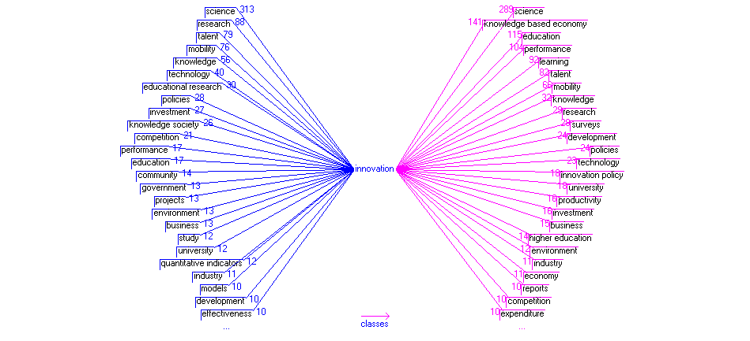

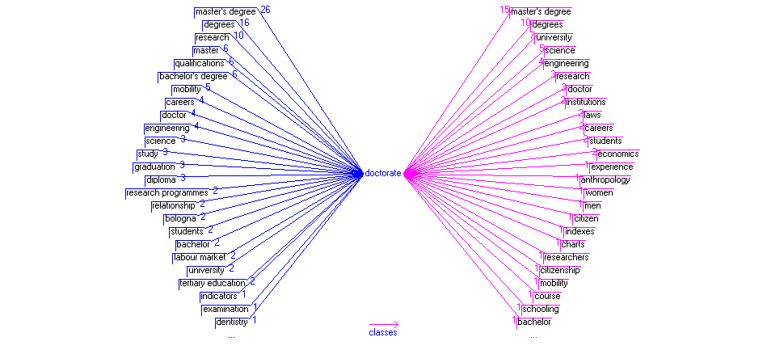

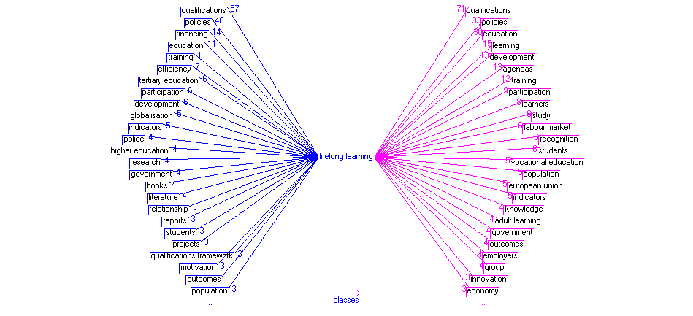

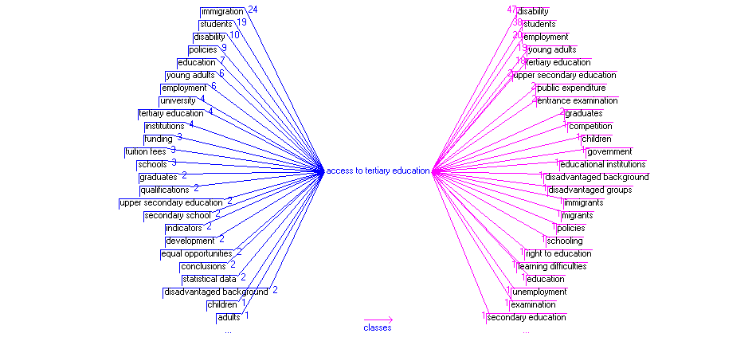

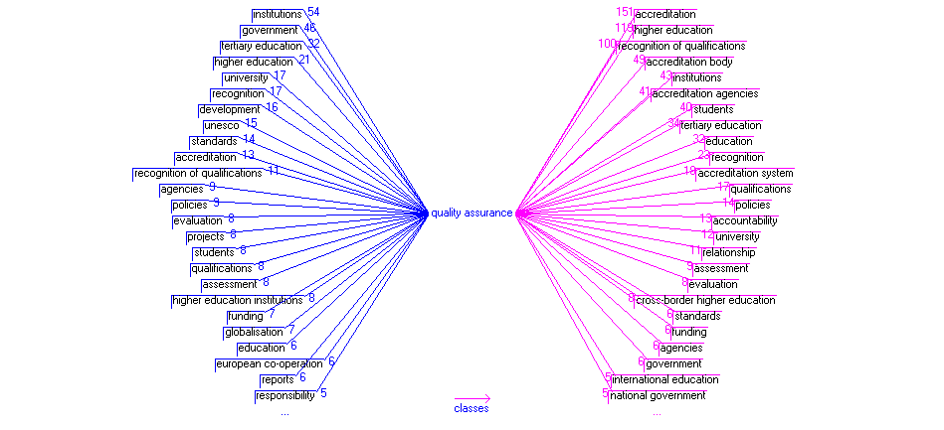

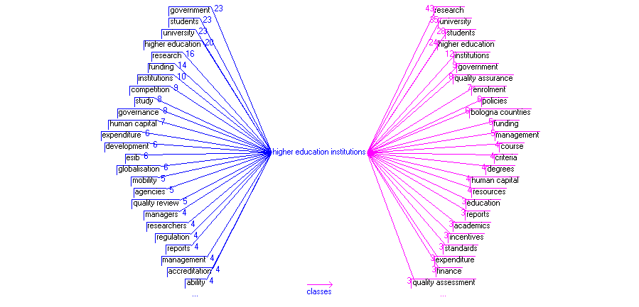

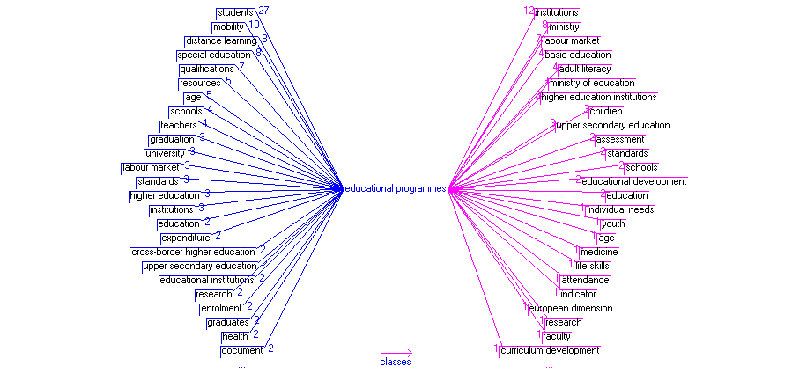

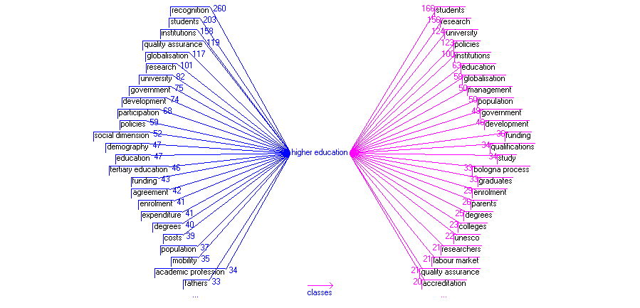

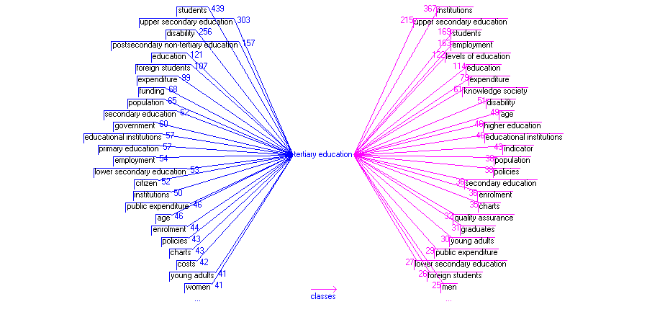

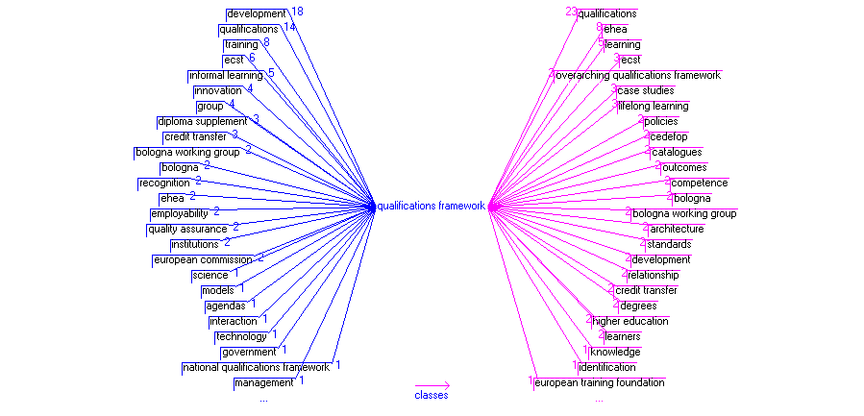

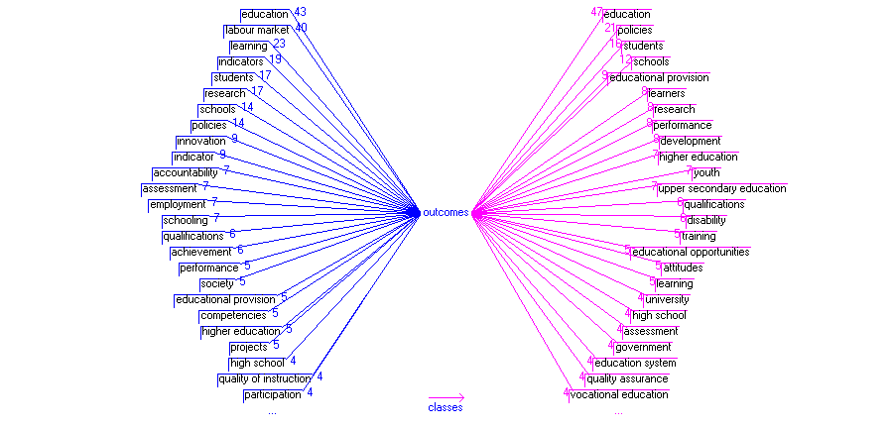

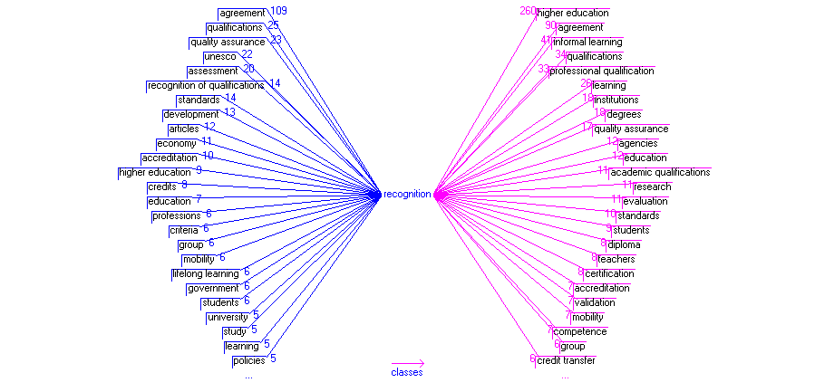

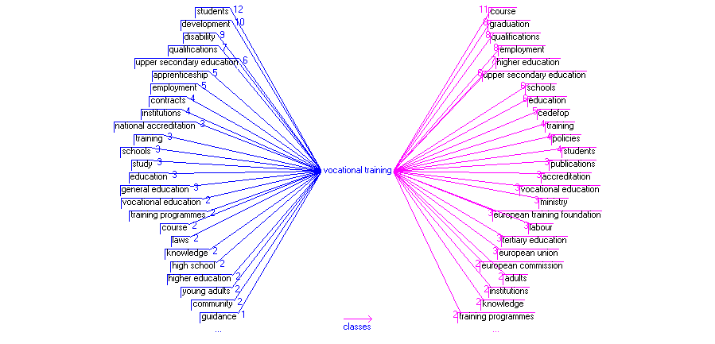

Din tema „Societate”, am selectat următoarele concepte:

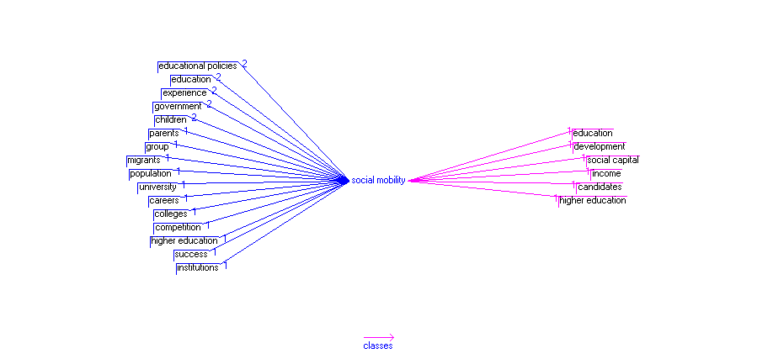

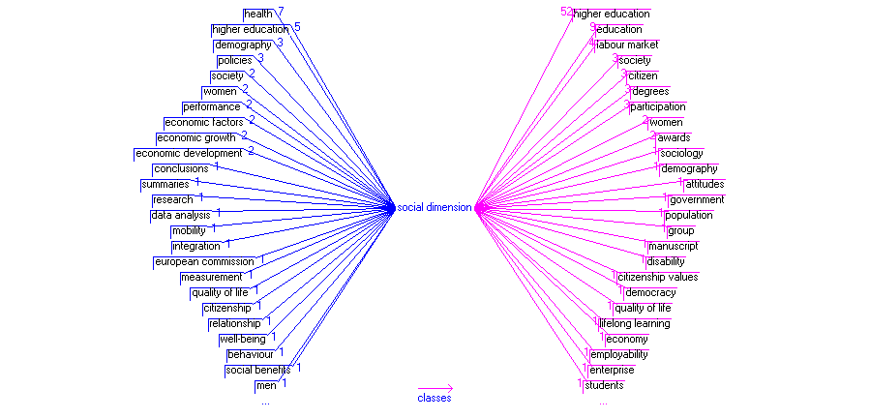

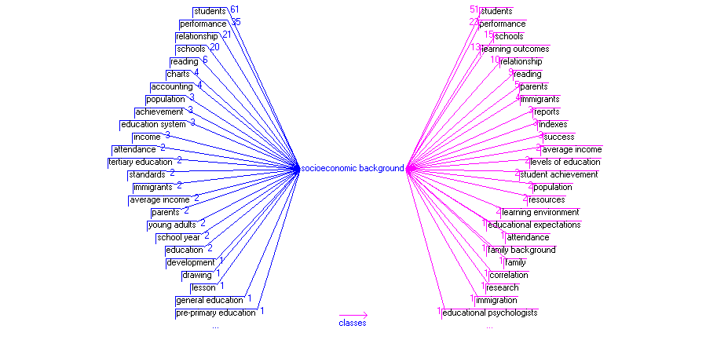

Din „Cercetare și tehnologie”, am selectat aceste concepte:

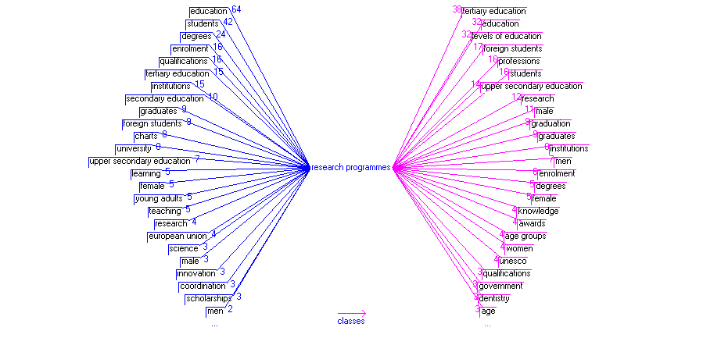

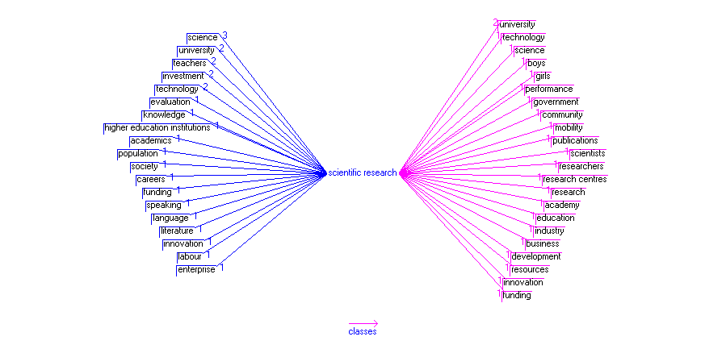

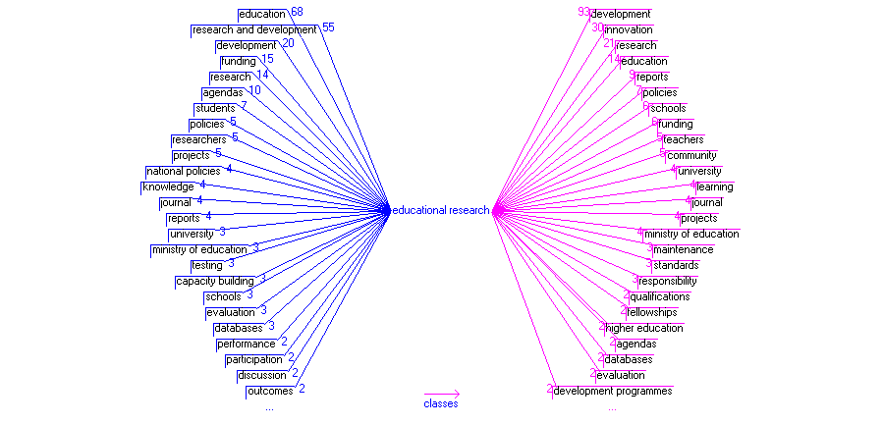

Din tema„Economie” aceste concepte prezintă un interes special pentru noi:

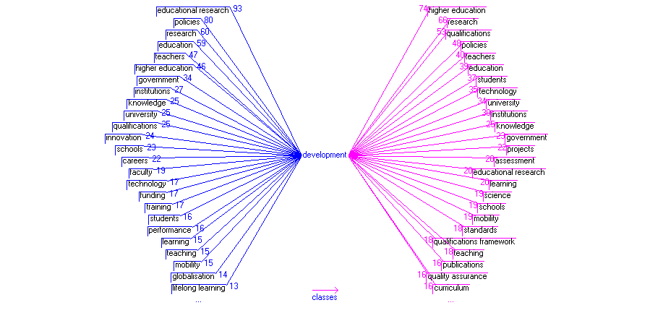

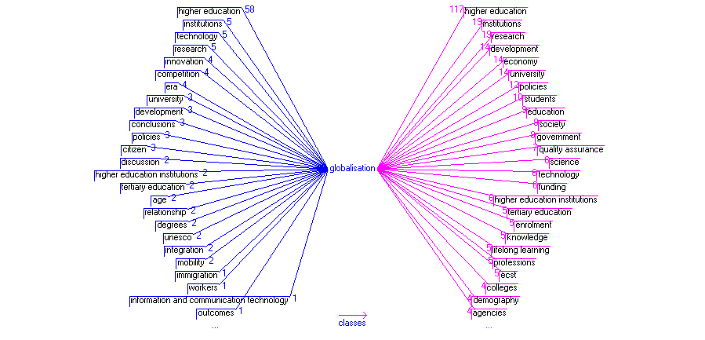

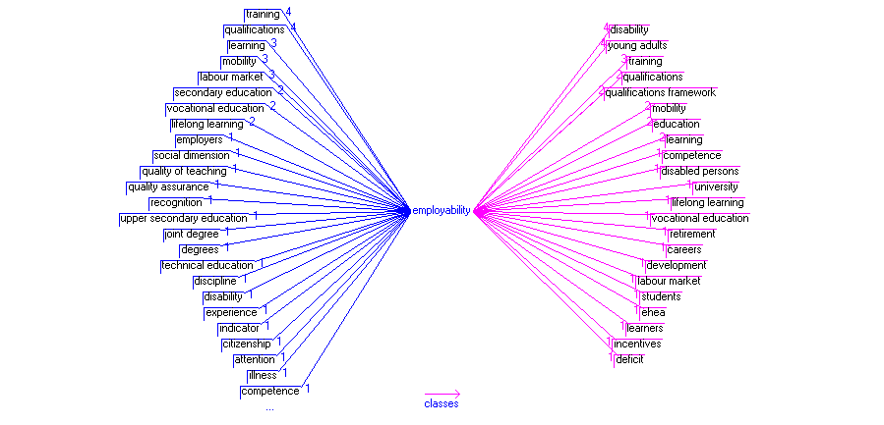

Vom încheia această selecție cu un grafic despre Procesul Bologna:

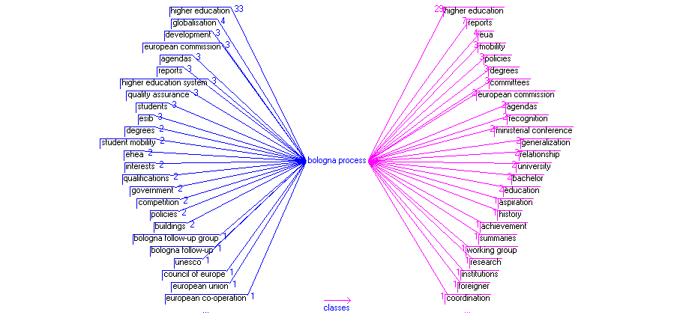

Ne putem întreba acum care sunt cele mai frecvente concepte ale corpusului, pentru stabilirea a ceea ce putem defini drept concepte cheie.

|  |  |  |
| --- | --- | --- |
| students | 15871 | 2 |
| education | 13670 | 2 |
| institutions | 6707 | 2 |
| secondary education | 6657 | 2 |
| higher education | 6097 | 3 |
| research | 5853 | 3 |
| university | 5669 | 3 |
| upper secondary education | 5056 | 3 |
| tertiary education | 4780 | 3 |
| achievement | 4686 | 2 |

Cu acest decagon vom face o nouă indexare a corpusului pentru a ajunge la modelul relațional (grafic), dar și la ceea ce putem numi nucleul conceptual al corpusului.

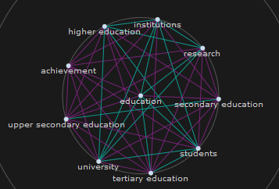

Relațiile cele mai puternice sunt marcate cu verde. Astfel, „education” este puternic conectată de „institutions”, „research”, „students”, „tertiary education” și „university”. Iată și un grafic de tip „hyper tree”, poate și mai lizibil:

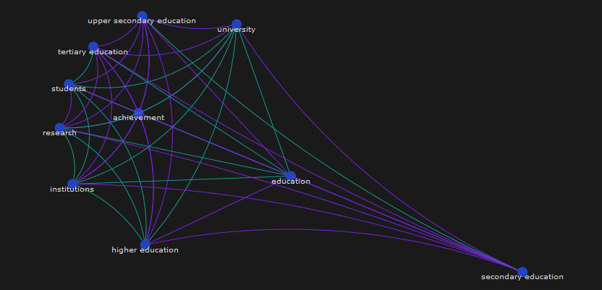

Nu ne mai rămâne decât să publicam datele matricei (cifrele se referă la numărul de texte care conțin relații binare):

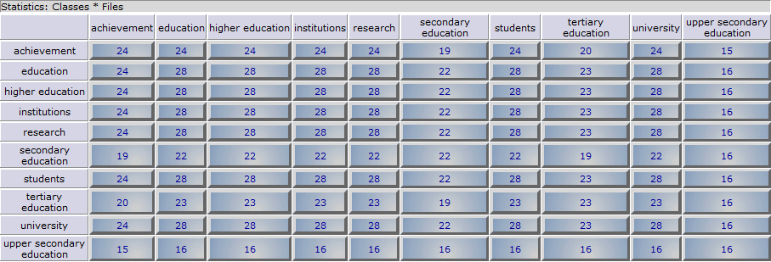

Analiza noastră se încheie aici, dar cercetătorii pot continua explorarea corpusului sau a unor concepte particulare.